

Faculty of Informatics and Computer Science

Information System/Computer Networks/Software Engineering/ Computer Science

FitNova: Fitness Planning, Form Detection, Nutrition Guidance

By: Ibrahim Shahin – 233243

Supervised By

Dr. Ahmed Fahmi

June 2026
Abstract
Generic workout and diet plans that are made for everyone ignore the individual characteristics of each person, so they are rarely the best choice for a specific user and a specific goal. Beginners also train in the gym without any feedback on their technique, which lowers their confidence and raises the risk of injury. FitNova is an AI fitness platform that tries to close these gaps by joining three connected modules in one system: a personalized workout planner, an exercise form-correction module, and a nutrition guidance module.

The aim was to build every module on a published dataset and a published method, so the work can be compared in a fair and honest way against prior research instead of relying on guesswork. The workout planner is a three layer pipeline. A content based filter scores a catalogue of 3,048 programs against the user profile, a Neural Collaborative Filtering model (NeuMF) re ranks the best candidates, and a four agent language model crew assembles a grounded seven day plan that only uses real exercises from the dataset. The form-correction module was rebuilt from scratch on the Fitness-AQA dataset and method, after an earlier pose based approach was found not to transfer to real video. Video errors such as the knees caving inward during a squat are detected with an R(2+1)D-18 three dimensional convolutional network trained with Motion-Disentangling self supervised pretraining, and a single image depth error is detected with a ResNet-18 trained with pose contrastive pretraining. The nutrition module computes calorie and macronutrient targets with a deterministic engine that guarantees correctness, selects recipes from a cleaned Food.com pool, and uses a four agent crew that only annotates the plan and never changes the numbers or invents food. A separate DistilGPT-2 model reproduces a recipe instruction generation task taken from the literature.

The system matches or beats the methods it was built on. On the official Fitness-AQA test splits the form models reach a higher macro F1 than the published method on all three exercises (Squat 0.6304 against 0.6262, overhead press 0.6622 against 0.6502, shallow squat 0.8902 against 0.8694), and checking for overfitting confirms that the deployed models generalize. The recommender reaches HR@10 of 0.9270 and NDCG@10 of 0.7469. The DistilGPT-2 generator beats all three learned models of the reference paper on the BLEU, ROUGE and Distinct text quality scores. The numbers are reported with their limits stated openly: the form models are measured on an in the wild benchmark and are still weak on casual front facing phone video, the recommender is trained on synthetic interaction data, and the recipe generator improves the quality of the text and not the personalization that was the original paper's main contribution.
Attestation &Turnitin Report
I understand the nature of plagiarism, and I am aware of the University’s policy on this.
I certify that this dissertation reports original work by me during my University project.

Signature Ibrahim Shahin Date 03/06/2026

Acknowledgements
Special thanks to my Supervisor Dr. Ahmed Fahmi for his time and effort and for leading the whole journey. And special thanks to all our modules teaching assistants who were always dedicated to show their support and help in time regarding any question or issues.
Table of Contents
Abstract ii
Attestation &Turnitin Report iv
Acknowledgements v
Table of Contents vi
List of Figures viii
List of Tables ix
1 Introduction 1
1.1 Overview 1
1.2 Problem Statement 2
1.3 Scope and Objectives 3
1.4 Report Organization (Structure) 4
1.5 Work Methodology 5
1.6 Work Plan (Gantt Chart) 6
2 Related Work (State-of-The-Art) 8
2.1 Background 8
2.2 Literature Survey 9
2.3 Analysis of the Related Work 13
3 Proposed solution 17
3.1 Solution Methodology 17
3.2 Functional/ Non-functional Requirements 20
3.3 Design / Simulation set up 26
4 Implementation 32
4.1 Fitness Planning Pipeline 32
4.1.1 Datasets 32
4.1.2 Layer 1: Content-based Filtering 35
4.1.3 Layer 2: Neural Collaborative Filtering 35
4.1.4 Layer 3: Plan Assembly and Validation 36
4.2 Form Correction Pipeline 37
4.2.1 Dataset and exploratory analysis 37
4.2.2 The Supervised Baseline 39
4.2.3 Motion-Disentangling self-supervised pretraining 40
4.2.4 The image error: ResNet-18 with pose-contrastive pretraining 42
4.2.5 Ensembles and serving 44
4.2.6 Approaches explored and cancelled 45
4.3 Nutrition Pipeline 47
4.3.1 The Food.com recipe data 48
4.3.2 Deterministic calorie and macro engine 48
4.3.3 Recipe selection and meal planning 49
4.3.4 Annotation Crew 50
4.3.5 Recipe-text generator 50
5 Testing and evaluation 53
5.1 Testing 53
5.2 Evaluation 55
6 Results and Discussions 58
6.1 Form Correction Results 58
6.2 Recommender results 61
6.3 Nutrition results 62
6.4 Discussion 64
7 Conclusions and Future Work 66
7.1 Summary 66
7.2 Future Work 67
References 69

List of Figures
Similarly you can automatically generate a list of figures from paragraphs of style Figure &Tables. To update this after revisions, right-click in the table and choose Update Field for the entire table.

Figure 1. Highly Technical Diagram 5

List of Tables

Introduction
FitNova is an AI fitness platform that brings workout planning, exercise form correction, and nutrition guidance into a single platform. This chapter explains what the project is and why it was built. It gives the background and the context of the work, states the problem that FitNova tries to solve, defines the scope and the objectives, and then describes the methodology and the work plan that were followed to build and evaluate the system.

Overview
Fitness applications that use artificial intelligence have become common. Instead of giving the same fixed program to everyone, they take a user profile (age, gender, body measurements, training goal, weekly availability) and try to produce a plan that fits that person [1]. This helps with planning, but two other parts of training are often left out. The first is technique. A workout plan tells a user what to do but not whether they are doing it safely, and a beginner who performs a movement with the wrong form can lose progress or get injured. The second is nutrition, which decides a large part of any fitness result and is often disconnected from the training goal. FitNova was built to cover all three of these areas in one place: planning, form correction, and nutrition.
The workout planning module takes the user profile and produces a seven day plan. It first scores a catalogue of training programs against the profile, then re ranks the best of them with a neural collaborative filtering model [2], and finally uses a small crew of language model agents to write the final plan using only real exercises from the dataset, so the plan can not contain invented movements. The form correction module looks at a video of the user performing an exercise and reports specific errors, for example the knees caving inward in a squat or the elbows drifting during an overhead press. Unlike many earlier systems that rely on pose estimation and fixed joint angle rules, this module learns the errors directly from the pixels of the video, using deep networks trained on the Fitness-AQA dataset, which provides real gym footage annotated by experts [3]. The nutrition module turns the same profile into calorie and macronutrient targets, then builds a daily meal plan from a large public recipe dataset (Food.com) [4], with the numbers computed by fixed formulas so they are always correct.
One idea runs through the whole project. Each module is built on a dataset and a method that were already published, and each one is measured with the same metrics that the original work used. This way the results can be compared directly with prior published work, using the same measures those papers used. It also means the report can be honest about the parts that did not work, because the form correction module in particular went through several earlier designs that were dropped before the final one was reached.

Problem Statement
Many gym users still train without a clear, personalized plan. They either follow a generic routine that was written for a general audience, or they go to the gym with no concrete plan at all. A generic plan ignores the things that make each person different, like their experience level, their goal, and how much time they can train each week, so it is rarely the best plan for that user. Machine learning recommenders can fix part of this by learning a plan from the user profile [1], but most of them stop at choosing exercises or building a schedule. They do not tell the user whether the movements are being performed correctly, and they do not connect the training to what the user should eat.
Knowing what to do is only half of training. Doing it with correct form is the other half, and it is where beginners struggle the most. A squat that is too shallow, knees that collapse inward, or elbows that drift on an overhead press are small mistakes that lower the benefit of the exercise and, over time, can cause injury. Detecting these mistakes automatically is harder than it looks. The common approach is to estimate the body as a skeleton of joints and then apply fixed rules on the joint angles. This works in a clean, controlled setup, but it becomes unreliable on real gym video, where the camera angle, the clothing, the lighting, and parts of the body being hidden all interfere with the pose estimate [3]. A system that is meant to be trusted has to handle these real conditions, and it has to be checked against a real benchmark instead of against easy examples that were picked to make it look good.
Nutrition is the third gap. The result of any training program depends a lot on diet, yet many users have no structured plan that matches their calorie and macronutrient needs. AI tools can write meal plans, and generative recipe models can even produce full cooking instructions [4], but a generated plan can be wrong in two different ways. The numbers can be wrong, for example a plan that does not actually reach the calorie or protein target, or that suggests an unsafe intake. The text can also be wrong, for example a recipe that is invented or that does not match the meal it claims to be. A useful nutrition feature has to keep the numbers correct first, and only then make the plan readable and specific.
These three problems are usually handled by separate tools, and many of those tools are hard to trust because they are tested on data that does not represent real use. FitNova treats the three as one problem: build a single platform that plans training, checks form, and guides nutrition, where every part is built on real published data and measured the same way the original research measured it, so the result can be defended against published work rather than only demonstrated.

Scope and Objectives
FitNova is made for everyday gym users, mostly beginners and intermediate trainees, who want their planning, their form feedback, and their nutrition in one place instead of spread across several apps that do not talk to each other. The user gives a profile once, and the same profile drives all three modules. The platform does not try to be a medical product. It supports a healthy training lifestyle and gives decision support, and it does not give clinical diagnosis or replace the advice of a doctor or a qualified coach [5].
The three modules are each kept to what their data can actually support. The workout planner produces a seven day plan from a catalogue of real training programs. The form correction module covers a fixed set of exercises and errors that come from the chosen dataset, the squat and the overhead press from video and a squat depth check from a single image, and it is judged on that dataset's in the wild test set. The module is not claimed to work on any casual front facing phone clip, because that is a harder setting than the data was collected for, and the report is clear about this limit later. The nutrition module produces calorie and macronutrient targets and a daily meal plan from a public recipe set, as guidance rather than a prescription.

FitNova was built with the following objectives:
- O1: Design an architecture that links personalized fitness planning, form correction, and nutrition guidance in a single AI platform, driven by one shared user profile.
- O2: Build a fitness planning module that takes the user profile (age, body metrics, training goal, experience level, and weekly availability) and produces a personalized workout plan, using a recommendation pipeline that scores candidate programs and re ranks them with a neural collaborative filtering model [2].
- O3: Tailor the plan to the user's goal, so that different goals such as weight loss, muscle gain, or endurance lead to clearly different training, and ground the final plan in real exercises from the dataset so it can not contain invented movements.
- O4: Build a form correction module that detects specific, named errors by learning directly from the raw video and images of a published in the wild dataset (Fitness-AQA) [3], instead of relying on pose estimation and fixed angle rules, and evaluate it with the same per error F1 score that the original work reports.
- O5: Build a nutrition module that computes calorie and macronutrient targets with a deterministic engine, selects real recipes that meet those targets and the user's constraints, and guarantees the nutritional correctness of the plan before any language model is used to describe it. This module also reproduces a published recipe text generation method [4] as part of the nutrition work.
- O6: Integrate the three modules into one working platform with a shared backend, so the output of one part can be used by the others.
- O7: Build every module on a published dataset and method, evaluate it with the same metrics as that prior work for a fair comparison, and report the results honestly, including the earlier form correction designs that were tried and dropped.

Report Organization (Structure)
This report has seven chapters. This first chapter introduces FitNova, states the problem it solves, sets the scope and the objectives, and describes the methodology and the work plan.
Chapter 2 reviews the related work in the three areas that FitNova brings together: workout recommendation, vision-based form assessment, and nutrition recommendation. It looks at what other systems did, what they got right, and where their limits are, and it explains why FitNova made the choices it made, in particular why the form-correction part moved away from pose-based methods to learning from raw video.
Chapter 3 describes the proposed solution at the design level. It gives the overall architecture, shows how the three modules share one user profile, lists the functional and non-functional requirements, and presents the data flow of each pipeline before any code detail.
Chapter 4 is the implementation, and it is the longest chapter. It covers each of the three pipelines in detail: the datasets and how they were prepared, the model architectures, the training procedures, and the serving layer. It also tells the honest story of the form-correction module, including the earlier designs that were built and then dropped.
Chapter 5 covers testing and evaluation. The testing part describes the unit and integration tests, the checks that stop the system from inventing numbers or recipes, and the method of the overfitting audit. The evaluation part defines the protocols and the metrics used for each module, so the numbers in the next chapter can be read correctly.
Chapter 6 presents the results and discusses them. It puts the form-correction scores next to the published baselines, reports the recommender and the nutrition numbers, and then steps back to discuss what the results mean and where they fall short, such as the rare error classes, the gap between the benchmark and casual phone video, and the use of synthetic interaction data.
Chapter 7 gives the conclusions and the future work. After that come the references and the appendices, which hold the user guide, the installation guide, and the extra figures and notebooks that support the main text.

Work Methodology
The methodology of this project rests on one main decision. Instead of designing new ad hoc methods and judging them only by how good the output looks, each module is built on a public dataset and a method that have already been published and reviewed, and each module is measured with the same metric that the original work used. This turns every part of FitNova into a reproduction that can be placed next to prior results and compared directly, and it gives an outside reader a fixed reference point to judge the system against. Each module's method is validated against that published baseline on real data, so the design rests on measured evidence rather than on appearances.
Because the quality of any learned model depends on the data it is trained on, the data is treated as the starting point of the methodology rather than an afterthought. For every dataset, the class balance, the meaning of each label, and the distribution of the inputs are studied before a model is designed, and the model and its training are then shaped around what the data actually contains. This matters most for the form-correction data, where the errors that the system has to detect are only a small fraction of the examples. Because of that imbalance the training uses a class-weighted loss, and the decision threshold for each error is chosen deliberately instead of left at one half, so that a rare but important error is not missed simply because it is rare.
For the workout planner the methodology is a layered recommendation pipeline rather than a single model. A content-based stage scores candidate programs against the user profile with interpretable weighted rules, a learned collaborative-filtering model then re-ranks the strongest candidates [2], and a language-model stage assembles the final seven-day plan. The layering is deliberate, because each stage covers a weakness of the others. The content-based rules work even for a brand new user who has no history for a learned model to use, the learned model picks up patterns that simple rules miss, and the language model turns the chosen program into a plan a person can actually read and follow. A hard constraint sits under the language stage so that it can only use real exercises from the dataset and can not invent movements, which keeps the readable output honest.
For form correction the methodology is to learn the errors directly from the raw pixels of the video and the images, with deep convolutional networks, instead of first reducing the body to a skeleton of joints and writing fixed rules on the angles [3]. Pose-based rules were set aside because a pose estimator is unreliable on real gym footage, where the camera angle, the clothing, and hidden body parts distort the skeleton, and a rule built on a wrong skeleton is wrong as well. The labelled error examples are few, so the methodology leans on self-supervised pretraining to make up for it. The network first learns a representation from a large pool of unlabelled clips through a task that needs no human labels, and it is fine-tuned on the small labelled set afterwards. A plain supervised model with no pretraining serves as the baseline, so the contribution of the pretraining is reported as a measured gain over it rather than assumed.
For nutrition the methodology keeps correctness and language apart. Every number, the calorie target, the macronutrient split, and the selection of recipes that fit them, comes from fixed formulas and explicit rules, so it is correct by construction. The language model is only allowed to describe and explain the plan that the deterministic part has already fixed. It can not change a number or pick a food. This makes a wrong calorie total or an invented recipe impossible by design, instead of an error that has to be found after the fact. The separate recipe-text generator is handled as a clean reproduction of a published model [4], trained and tested on the same task and the same split as the original, so its quality can be compared metric for metric.
The same thinking carries into evaluation. Each dataset is used with its official train, validation, and test split exactly as released, so every number in this report is computed on the same test data as the work it is compared against. Any threshold or decision cut is set on the validation split alone, and the test split is held back until the final measurement, so the reported scores are not quietly tuned to the test set. The metrics are taken from the source papers too, the F1 score for each form error [3], the hit rate and the normalised discounted cumulative gain for the recommender [2], and the standard text-overlap and diversity scores for the recipe generator [4], so that the comparison is like for like. The training and the test behaviour of each model are then compared, to confirm that a score comes from real generalisation and not from a model that has only memorised its training examples.

Work Plan (Gantt Chart)

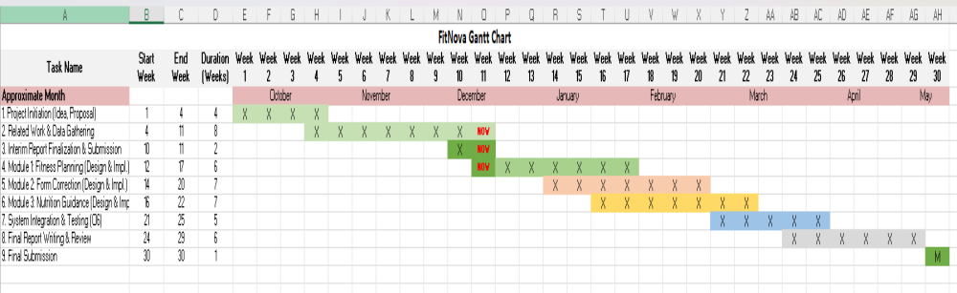
Figure 1 - Gantt Chart
The project followed a 30-week plan that ran from October to May, shown in the Gantt chart in Figure 1. The plan used an incremental, module-by-module approach [6], where the three modules were designed and built in their own overlapping windows rather than all at once, so that work on a later module could begin before the previous one was fully finished.
The first 4 weeks covered project initiation, the idea and the proposal. Related work and data gathering came next, from week 4 to week 11, running alongside the early planning, and this is where the datasets for the three modules were located and collected. Related work and data gathering were given a full eight weeks of their own, before any module was built, which matches the data-first approach set out in the methodology. The interim report was finalised and submitted around weeks 10 and 11.
Implementation then moved one module at a time. The fitness planning module was designed and built across weeks 12 to 17. The form correction module followed, from week 14 to week 20, overlapping the planning work. The nutrition guidance module ran from week 16 to week 22. The overlap between the three was planned on purpose, so the data preparation and the model training for one module could run while another was being written.
System integration and testing, which covers objective O6, took weeks 21 to 25, once the three modules existed and could be connected through the shared backend. The final report was written and reviewed across weeks 24 to 29, again overlapping the end of integration, and the final submission was made in week 30. The work kept to this schedule, and each phase was completed inside its planned window.

Related Work (State-of-The-Art)
FitNova sits across three research areas, and each of its modules builds on a different body of prior work. This chapter reviews that work. It starts with the background of the three areas and the main techniques behind them, then surveys the specific systems and studies that are closest to FitNova, and ends with an analysis of what the prior work does well, where it falls short, and how those gaps shaped the design of this project.

Background
The workout planner belongs to the field of recommender systems. Classical recommender systems fall into two main styles. Content-based filtering recommends items whose features match what a user already likes or what the user's profile asks for, using a similarity between item attributes and the user description [7]. Collaborative filtering instead learns from the behaviour of many users at once, and its most successful classical form is matrix factorization, which places users and items as vectors in a shared latent space and predicts a preference from their dot product [8]. Matrix factorization is linear, so it can miss more complicated relations between a user and an item. Neural collaborative filtering answers this by replacing the dot product with a small neural network that can learn a non-linear interaction between the user and the item, and this is the model that FitNova's planner is based on [2].
The form correction module belongs to computer vision, and to the part of it that works with the human body in video. Deep convolutional neural networks changed image recognition when a deep network trained on a large labelled image set clearly beat the older hand-designed features [9], and residual networks such as ResNet then made very deep models practical to train by letting each layer learn a small change on top of its input [10]. Going from a single image to video adds a time dimension. One strong and widely used way to handle that dimension is the R(2+1)D network, which splits a three-dimensional convolution into a spatial part and a separate temporal part, and which FitNova uses for its video models [11]. A different line of work does not look at the raw pixels at all, but first estimates the positions of the body joints. On-device pose estimators such as BlazePose made this fast enough to run in real time on a phone [12], and many fitness applications are built directly on a pose estimator of this kind. The narrower task of judging how well an action is performed, rather than which action it is, is called action quality assessment [13], and detecting a specific form error is a fine-grained case of that task.
The nutrition module sits in nutrition informatics. The energy a person needs in a day is normally estimated in two steps, first a resting metabolic rate from body measurements, then an activity factor multiplied on top of it, and the Mifflin-St Jeor equation is one of the most widely used and most accurate predictors of that resting rate [14]. On top of these fixed calculations, recent work has put machine learning and generative models into nutrition, for example to build weekly meal plans that respect calorie and nutrient limits, sometimes adding a language model so the output reads naturally [15]. A related line of research treats cooking as a language task and learns to generate the recipe text itself, and this is the task that FitNova reproduces in its recipe-text component [4]. Reviews of artificial intelligence in nutrition warn that systems like these should stay as decision support and must not replace clinical advice [5].

Literature Survey
Several recent systems recommend workouts from a user profile. Gedi et al. built a personalized gym recommendation system on a public dataset of 14,589 records with 18 columns of user data, such as age, body metrics, and stated goals, and trained eight machine learning models for both classification and regression on it [1]. They report that a decision tree reached very high scores, 99.95% on the test set for the regression target and 92.22% for the classification target, inside a pipeline of user input, data processing, analysis, a recommendation engine, and a feedback loop that updates with performance. Numbers that high usually mean the model has fit that one dataset very closely, and the work stays at the level of choosing a workout, with nothing said about how the exercises are performed or about nutrition. Sareen et al. went a step wider and joined fitness and diet in a single platform [16]. Their system gathers user inputs through a web form, passes them through data acquisition, preprocessing, model selection, and recommendation, and then shows several routine and meal options that adapt to the user's preferences and feedback through a React interface. These two systems are representative of a large family of profile-only recommenders. They show that a structured profile can drive a useful plan, but they treat the plan as the end of the job and do not check execution or verify the nutrition they suggest.
A second group of systems uses richer behavioural data. Ni et al. proposed FitRec, which models a user's heart rate and activity logs from wearable devices with a long short-term memory network, so that the recommendation reflects how a specific person's body responds during exercise and not only a static profile [17]. FitRec is more powerful than the profile-only systems, but it needs continuous sensor histories that an app without wearable integration does not have. Underneath these applications sit the standard recommender techniques. Matrix factorization represents users and items in a shared latent space and reads a preference from their product [8], neural collaborative filtering replaces that fixed product with a small network that can learn a non-linear interaction [2], and sequential models such as the self-attentive recommender SASRec read a user's ordered history of past choices to predict the next one [18]. The sequential models are strong when a real history of user behaviour exists, which is exactly what a new fitness platform does not have at the start, so FitNova works from the user profile and a collaborative-filtering model rather than from a sequence of past behaviour.
Most form-feedback systems in the literature are built on pose estimation. Tiwari et al. detect mistakes in squats, curls, planks, and lunges by reading MediaPipe pose landmarks and applying thresholds on joint angles and distances, and they report errors in plain language, such as an incorrect squat stance or a wrong knee position [19]. Ohri et al. build a similar personal-trainer system on BlazePose and OpenCV, drawing a skeleton from a webcam, computing joint angles, counting repetitions, and giving corrective feedback through a web interface and a chatbot for home workouts [20]. Jagadale et al. again use BlazePose to recognise several exercises and analyse posture, and they are honest about the weak points of the approach, that it is sensitive to camera position and to lighting [21]. These are practical, low-cost systems, and they work in tidy conditions, but they all inherit the reliability of the pose estimate sitting underneath them, and they reduce form to a few hand-written angle rules that a coach would treat as only a small part of good technique.
Academic work pushed the pose-based idea much further. Ogata et al. classified squat form from pose using temporal distance matrices, and ran into a clear limit when keypoints in the spinal region went missing [22]. Fieraru et al. presented AIFit, which fits a detailed 3D human model to fitness videos, segments the repetitions, and turns the joint trajectories into interpretable, human-readable feedback about what the trainee did wrong, with the angular signature of the movement at its centre [23]. AIFit is one of the strongest results in this direction and shows how much can be read from an accurate 3D reconstruction, but that accuracy is also its condition, it was built and measured with studio motion capture, and a clean 3D reconstruction is realistic in a capture lab and far less realistic in an ordinary gym. Across the whole pose-based line there is one shared weakness. Every method rests on a skeleton, and the skeleton becomes unreliable in real gyms because of camera angle, occlusion, clothing, and lighting, so a rule or a model built on top of it carries those errors forward.
A method is only as good as the data it learns from, and the datasets used for form assessment differ most in the kind of labels they carry. Fit3D, released with the AIFit work, is a large motion-capture dataset, with over three million frames of instructors and trainees performing dozens of exercises, each frame carrying an accurate 3D body configuration from a controlled capture studio [23]. The 3D ground truth is excellent, but the dataset has no labels for specific form errors, and a capture studio is a long way from a real gym, so any system that wants to detect mistakes from it has to invent the mistakes itself, usually by perturbing a clean repetition and calling the perturbation an error. A perturbation is not a real mistake, and a model trained on perturbed motion capture tends not to carry over to a real person filmed on a phone. The QEVD dataset, from Qualcomm, sits at the other end [24]. It is large and real, more than 460 hours of video from over 1,900 participants across 148 exercises, and it even contains people making common mistakes on purpose, but its labels are natural-language coaching messages, about two short pieces of spoken feedback per clip, and not a clean yes or no for each named error. Turning free coaching text into the structured per-error labels that a classifier needs is noisy, and the wording tends to follow the exercise type more than the fine detail of the form, so a model trained on labels pulled from the text can end up guessing the exercise instead of judging the movement. Fitness-AQA takes the harder and more useful path [3]. Its videos are real and recorded in the wild, and its labels are the per-error annotations made by expert trainers, a clean marker for each specific mistake. That match between real video and real per-error labels is why FitNova learns from Fitness-AQA, and why Fit3D and QEVD, useful as they are for 3D reconstruction and for language-based coaching, were set aside for the narrower task of detecting named form errors.
The task of judging how well a movement is performed, rather than which movement it is, is studied under the name action quality assessment [13], and detecting a named form error is a fine-grained case of it. The Fitness-AQA work of Parmar et al. attacks this case directly and is the basis of FitNova's form module [3]. Rather than estimating a skeleton, it learns representations straight from the raw pixels of the gym footage, with two self-supervised strategies that need no manual labels: Motion Disentangling, which learns from the structure of the barbell's motion across a repetition, for the video errors, and Cross-View Cross-Subject Pose Contrastive learning, which learns from matched poses seen across different camera views and different people, for the single-image depth error. Both are contrastive methods, the same family of idea that SimCLR made popular for images, where a network learns useful features by pulling together two views of the same example and pushing apart different examples with no labels at all [25]. After this label-free pretraining, only a small expert-labelled set is needed to train the final error detector. The strength of the route is that it never has to trust a skeleton, so it survives the real-gym conditions that break the pose-based systems.
Two later works build on the same dataset and are worth placing next to it. Gallardo et al. proposed GYMetricPose, which goes back to a pose representation but in a richer form, estimating 2D keypoints, lifting them to 3D, and feeding a graph that carries angular information through edge-gated convolutions before a binary error classifier [26]. Dibenedetto et al. instead fine-tuned a large multimodal model, LLaVA-Video, on the same dataset, reformatting the labels into a conversation with time stamps so that one model can name the error and locate it in time across different exercises [27]. The multimodal model has a real strength, it generalises across exercises with a single network and no per-exercise retraining, but it comes with limits that matter for a fair comparison. It slightly underperforms the specialised baselines, it is very weak on the rare errors such as the knees caving inward, it folds the validation split into its training data, and it is heavy to run, limited to 32 frames per clip even on GPUs with 64 GB of memory. For these reasons FitNova builds on the original Fitness-AQA method, and treats both later works as context rather than as a like-for-like comparison.
On the nutrition side the literature splits between fixed calculation and learned generation. The fixed part is well established. Daily energy is estimated from a resting metabolic rate and an activity factor, and the Mifflin-St Jeor equation remains one of the most used and most accurate predictors of that resting rate [14], which is why it is a sound backbone for any system that has to keep its calorie numbers correct. On top of this, recent systems add learned components. Papastratis et al. combine a deep generative model with a language model to produce weekly meal plans that respect calorie and nutrient limits [15], and Kalpakoglou et al. report an AI nutrition recommendation system that builds a personalized Mediterranean diet and put it through a technical validation [28]. These show that meal planning under constraints can be automated, but they also show how much care the constraint handling needs, because a generated plan that drifts off its targets is worse than no plan.
A separate and more language-focused line treats cooking itself as a generation problem. Majumder et al. learn to write personalized recipe text from a user's history on the Food.com data, conditioning the generated cooking steps on what the user has cooked before [4]. The wider research on recipes is supported by large public corpora, such as Recipe1M+, which gathered more than a million recipes and millions of food images for learning across text and vision, and which shows the scale at which recipe text is now studied [29]. Reviews of artificial intelligence in nutrition strike a careful note across all of this work, warning that systems like these should stay as decision support and must not replace professional or clinical advice [5]. FitNova is built directly around these two lessons. It makes the calorie, the macronutrient, and the recipe choices with fixed rules so the numbers can not drift, and it uses a language model only to describe the plan and never to choose food or change a number, which removes the failure modes the reviews warn about.

Table 1 - Datasets for form assessment
Dataset | Data and Environment | Labels | Scale | Fit for fine-grained form-error detection
Fitness-AQA [3] | Real in-the-wild gym videos and images from public platforms | Expert per-error annotations, a clean yes or no for each named error. | Squat 1,623, OHP 2,260, Shallow-Squat 3,611, large unlabeled pools for self-supervision | High: real footage with real per-error labels, the exact match this task needs (the dataset FitNova uses)
Fit3D [23] | Motion capture in a controlled studio, Instructors and trainees | Accurate 3D body pose per frame; no labels for specific form errors | Over 3 million frames, 37+ exercises | Low: errors must be invented by perturbing clean repetitions.
QEVD [24] | Real crowd-sourced video, including people making deliberate mistakes | Natural-language coaching messages, about two per clip; no clean per-error label | 460+ hours, 1,900+ participants, 148 exercises | Low to medium: structured labels must be pulled from free text, which is noisy and tracks the exercise more than the form

Analysis of the Related Work
Looking across the three areas together, a clear pattern shows up. In each one, prior work has solved a part of the problem well but leaves a gap that matters for a platform that wants to be trusted. The recommenders personalize a plan but stop there. The form systems give feedback but lean on a fragile skeleton, or on data whose labels do not match real form. The nutrition systems generate plans but do not guarantee that the numbers are right. FitNova is designed around closing those specific gaps, and around one rule that runs through every choice: build on a published dataset and method, and measure with the same numbers the original work used, so each claim can be checked.
For workout recommendation, the profile-only systems of Gedi et al. and Sareen et al. show that a structured profile is enough to produce a reasonable plan, and the very high accuracy that Gedi et al. report is more a sign of close fitting to one dataset than of a hard problem solved [1], [16]. The richer systems point the other way. FitRec shows that real behavioural signals from wearables produce a more personal recommendation, but it needs continuous sensor data that a phone app without device integration does not collect [17]. Sequential recommenders such as SASRec are powerful, yet they assume a real history of user choices to read from [18], and a new platform has none. This is the honest position FitNova starts from. It has user profiles and a program catalogue but no real interaction history, so it builds the plan with a content-based filter and a neural collaborative filtering model, the method of He et al. [2], and it is open in this report that the interactions used to train that model are synthetic. The recommender therefore reproduces the NeuMF method faithfully and is measured with the same hit-rate and ranking metrics as the original work, and it is not presented as proof of real-world recommendation quality, which would need real user behaviour to claim.
For form assessment the analysis is sharper, because the prior work splits cleanly on one question, whether to trust a skeleton. The consumer systems of Tiwari, Ohri, and Jagadale, and the stronger academic system AIFit, all read the body as a set of joints and then reason about angles [19], [20], [21], [23]. This works in controlled conditions and breaks in real gyms, where the camera angle, occlusion, clothing, and lighting all damage the pose estimate, and a rule built on a damaged skeleton is damaged as well. The datasets behind this work tell the same story in a different way, summarised in Table 1. Fit3D gives perfect studio pose but no real form-error labels, so any error has to be invented and does not transfer [23]. QEVD gives real video but labels it with free coaching text that follows the exercise more than the fine detail of the form [24]. Fitness-AQA is the one dataset that pairs real in-the-wild video with clean per-error labels from expert trainers [3], which is exactly what supervised error detection needs. This is why FitNova learns directly from the pixels on Fitness-AQA, with the self-supervised pretraining of Parmar et al., instead of estimating a pose. The two later works on the same dataset confirm the choice rather than overturn it. GYMetricPose returns to a pose graph and is reported only second-hand here, with an unverified split protocol [26], and the multimodal model of Dibenedetto et al. is a single network that spans exercises but underperforms the specialised method, is weak on the rare errors, folds the validation split into training, and is far heavier to run [27]. FitNova reproduces the specialised method and reports identical per-error F1, which is the comparison that can actually be defended.
For nutrition, the generative systems of Papastratis et al. and Kalpakoglou et al. prove that meal planning under calorie and nutrient limits can be automated [15], [28], and the recipe work of Majumder et al. proves that readable cooking text can be generated from a user's history [4]. The shared risk in this line is that a learned model can drift off its targets or write something that is not real, and the reviews of AI in nutrition are explicit that such tools must stay as decision support and not replace professional advice [5]. FitNova answers this by separating the two jobs. The calorie target, the macronutrient split, and the choice of recipes are produced by fixed rules, so they are correct by construction, and the language model is only allowed to describe the plan, never to choose food or move a number. The recipe-text generator is kept as a clean reproduction of Majumder et al. on the same task and the same split, so its text quality can be compared metric for metric, while the report is clear that it does not reproduce the original paper's personalization, which it did not set out to do.
The table below places the most relevant systems side by side with their approach and the gap that FitNova has to cover. Read together, the prior work does not point to a single missing model, it points to a missing discipline. Each area already has methods that work in the conditions they were tested in, and the value of bringing them into one platform comes from holding every part to the same standard: a real dataset, a published method, the original metrics, and an honest statement of where the result stops being reliable. That standard is what the rest of this report follows.
Table 2 - The most relevant prior systems, their approach, and the gap FitNova covers
Work | Area | Approach | Main Limitation for FitNova Goal
Gedi et al. [1] | Workout recommendation | Eight ML models on a profile dataset; a decision tree is best | Only picks a workout; near-perfect scores suggest dataset overfit; no form or nutrition
Ni et al., FitRec [17] | Fitness recommendation | LSTM over wearable heart-rate and activity logs | Needs continuous sensor history a new app does not have
Tiwari, Ohri, Jagadale [19], [20], [21] | Form feedback | MediaPipe or BlazePose plus joint-angle thresholds | Skeleton unreliable in real gyms; form reduced to a few rules
Fieraru et al., AIFit [23] | Form feedback | 3D human model with interpretable angular feedback | Needs accurate studio 3D reconstruction, not realistic in a gym
Parmar et al., Fitness-AQA [3] | Form-error detection | Raw-pixel self-supervised learning on real video | The method FitNova adopts
Gallardo et al., GYMetricPose [26] | Form-error detection | 2D to 3D pose graph with angular edges | Returns to a pose representation; reported second-hand with an unverified split
Dibenedetto et al., LMM [27] | Form-error detection | Fine-tuned LLaVA-Video, one model across exercises | Underperforms specialists, weak on rare errors, trains on validation, heavy
Papastratis, Kalpakoglou [15], [28] | Nutrition | Generative and language-model meal plans under constraints | Constraint drift risk; correctness not guaranteed
Majumder et al. [4] | Recipe generation | Personalized recipe text from user history | The text task FitNova reproduces; personalization not adopted

Proposed solution
This chapter describes the proposed solution at the design level, before the implementation detail of Chapter 4. It starts with the solution methodology, the three pipelines and the way they fit into one system, then sets out the functional and non-functional requirements, and finishes with the design of each pipeline and the data that flows through it. The aim here is the shape of the system and the reasons behind it.

Solution Methodology
FitNova is one backend service that hosts three independent modules behind a single application. A user provides a profile, the backend loads the three modules at startup and keeps them ready in memory, and each module answers the requests that belong to it through its own endpoints. The modules do not depend on each other to run, so a failure in one does not take the others down, but they are tied together by two things: the user, whose profile and goal are the common starting point, and a single design principle that shapes all three. That principle is to put a deterministic, rule-based core wherever correctness matters, and to let a language model speak only on top of a result that is already correct. The planner can only choose real programs and real exercises, the nutrition engine computes every number with fixed formulas, and the form models output a measured probability against a fixed threshold. A language model then explains the workout plan and the meal plan in readable words, but it is never the thing that decides them.
The figure below (Figure 2) shows how the parts fit together. The user and the client app sit at the top, the backend in the middle holds the three pipelines side by side, and the datasets that each pipeline was built on sit at the bottom. Reading each column from top to bottom gives the flow of one feature, and the three columns share only the backend and the user, which is the level at which the system is integrated.
Figure 2 - FitNova overall system architecture.
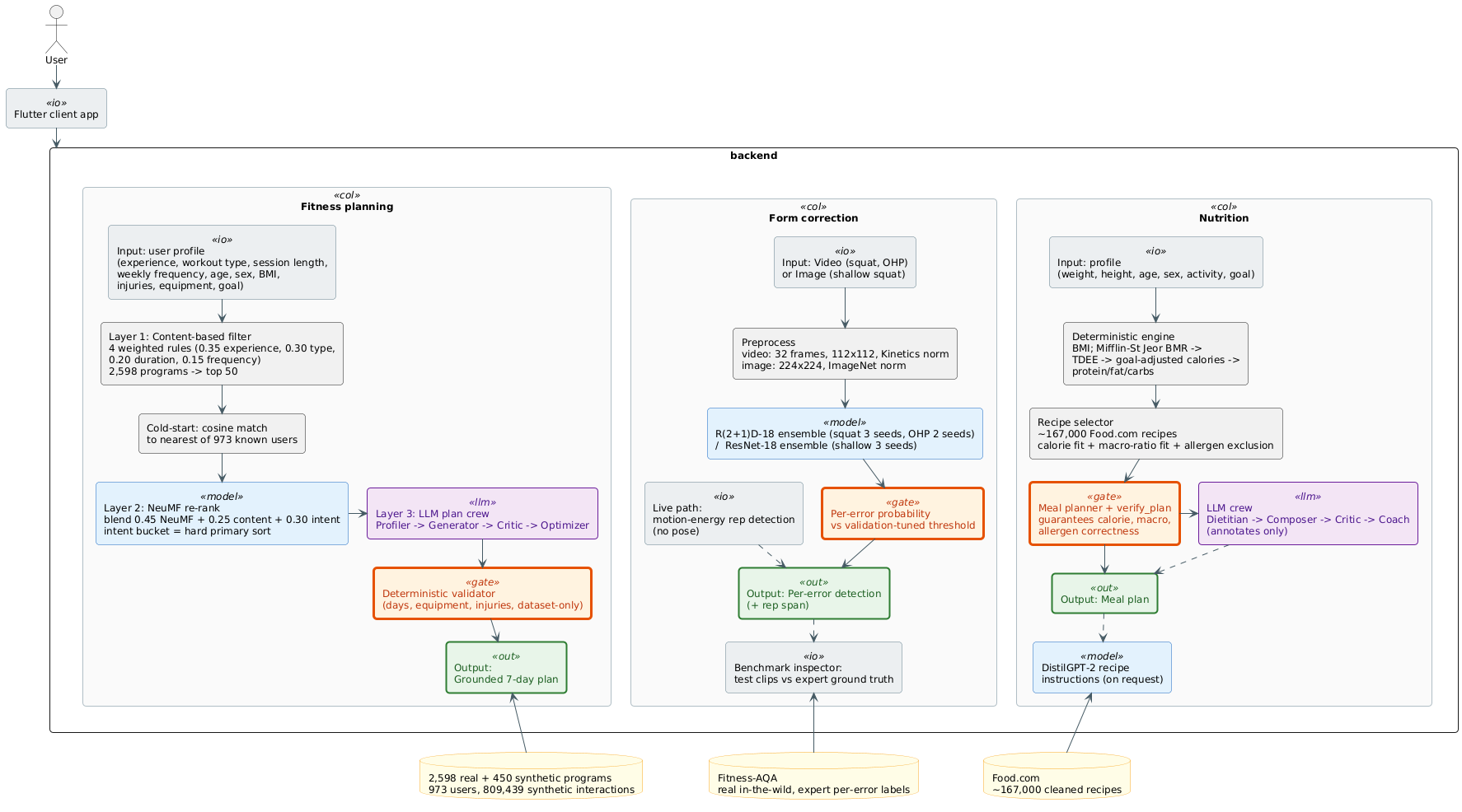
Two things are worth reading off the diagram. The first is that every pipeline ends in a deterministic step, the validated plan, the verified meal plan, and the thresholded detection, so the output a user sees has already passed a fixed check before any model's opinion is attached to it. The second is that the language models, drawn as the crews, sit to the side of the main flow rather than in the middle of it. They receive a finished result and add words; they do not stand between the data and the decision. The rest of this section walks down each of the three columns in turn.
The fitness planning pipeline is built as three layers, in the spirit of a hybrid recommender that does not rely on any single technique. The first layer is a content-based filter that scores every program in the catalogue against the user profile with four weighted rules, experience level, workout type, session length, and weekly frequency, and keeps the fifty best [7]. The second layer is the learned one. Because a brand new user has no history for a collaborative model to read, the system first finds the most similar of the 973 known users by cosine similarity on the profile, then uses a Neural Collaborative Filtering model, the method of He et al., to re-rank the fifty candidates for that surrogate user [2]. The two signals are blended, with the user's stated intent kept as the dominant sort key so that a plan always matches the goal the user asked for. The third layer turns the chosen program into a readable seven-day plan. A small crew of language model agents, a Profiler, a Generator, a Critic, and an Optimizer, drafts and refines the plan, but it may only use exercises drawn from the chosen program, and a deterministic validator checks the result against the user's training days, equipment, and injuries and repairs anything that breaks a rule. An invented exercise can not survive this step, because anything not in the dataset pool is dropped.
The form correction pipeline takes a different kind of input, a short video or a single image of a lift, and turns it into a yes or no for each named error. The video errors, the knees caving inward and the knees travelling too far forward in a squat, and the elbows and the knees in an overhead press, are read by an R(2+1)D-18 three-dimensional convolutional network [11], and the single depth error in a squat is read by a ResNet-18 image network [10]. Each clip is sampled to thirty-two frames, cropped, and normalised the same way the network was trained, then passed through a small ensemble of models trained from different random seeds, whose probabilities are averaged for a steadier answer. The averaged probability for each error is compared with a threshold that was tuned on the validation data, and the error is reported only when the probability clears it. For a recorded clip the whole repetition is judged at once, and for the live camera path a light motion-energy step, which needs no pose estimate, watches the movement and fires the model at the moment a repetition ends. The same models also drive a benchmark inspector, which runs them on the dataset's own test clips and shows the result next to the expert ground truth, so the output can always be checked.
The nutrition pipeline is the clearest example of the deterministic-first principle. It begins with a fixed calculation. From the user's weight, height, age, and sex it computes a resting metabolic rate with the Mifflin-St Jeor equation, multiplies it by an activity factor to get the daily energy need, adjusts that for the goal of losing, maintaining, or gaining, and splits the result into protein, fat, and carbohydrate targets, all with set formulas and safe floors [14]. A selector then searches a cleaned pool of about 167,000 Food.com recipes for items that fit the calorie target and the macro ratio and respect the user's allergies, and a planner arranges the chosen recipes into a day, or a week, of meals and runs a final check that the totals land on target and that nothing forbidden slipped in. Only after all of this does a second crew of language model agents, a Dietitian, a Composer, a Critic, and a Coach, add a plain-language explanation, day themes named from the real recipes, a quality note, and practical tips. The crew never picks a food or moves a number, so a broken calorie total or an invented recipe is impossible by design [4]. A separate DistilGPT-2 model writes step-by-step cooking instructions for a recipe when asked, which is a reproduction of a published generation task and is kept apart from the part of the system that has to be correct.
The three pipelines are connected by a shared shape rather than by a shared model or a shared dataset. Each one is grounded in a public dataset, each one keeps its numbers and its choices inside a deterministic core, each one is measured with the metric its source work used, and each one only lets a language model speak once the result is already settled. The planning and the nutrition features lean on this most heavily, because they produce something a user will act on, and the form feature adds to it the discipline of reporting a raw probability against a fixed line rather than a softened verdict. The sections that follow turn this methodology into concrete requirements and a detailed design.

Functional/ Non-functional Requirements
This section states what FitNova has to do and the qualities it has to have. The functional requirements are the behaviours a user can ask for, and the non-functional requirements are the standards those behaviours must meet, the most important of which is that the system never shows a number or a result it can not stand behind.
Figure 3 is the use-case view of the platform. There is a single actor, the user, who works with one application that fronts all three modules. The user is the only actor, because FitNova has no second human role in the loop, no separate trainer or administrator, and the language models inside the system are services rather than actors, so they never appear on the diagram and never act on their own.
Figure 3 - Use Case Diagram
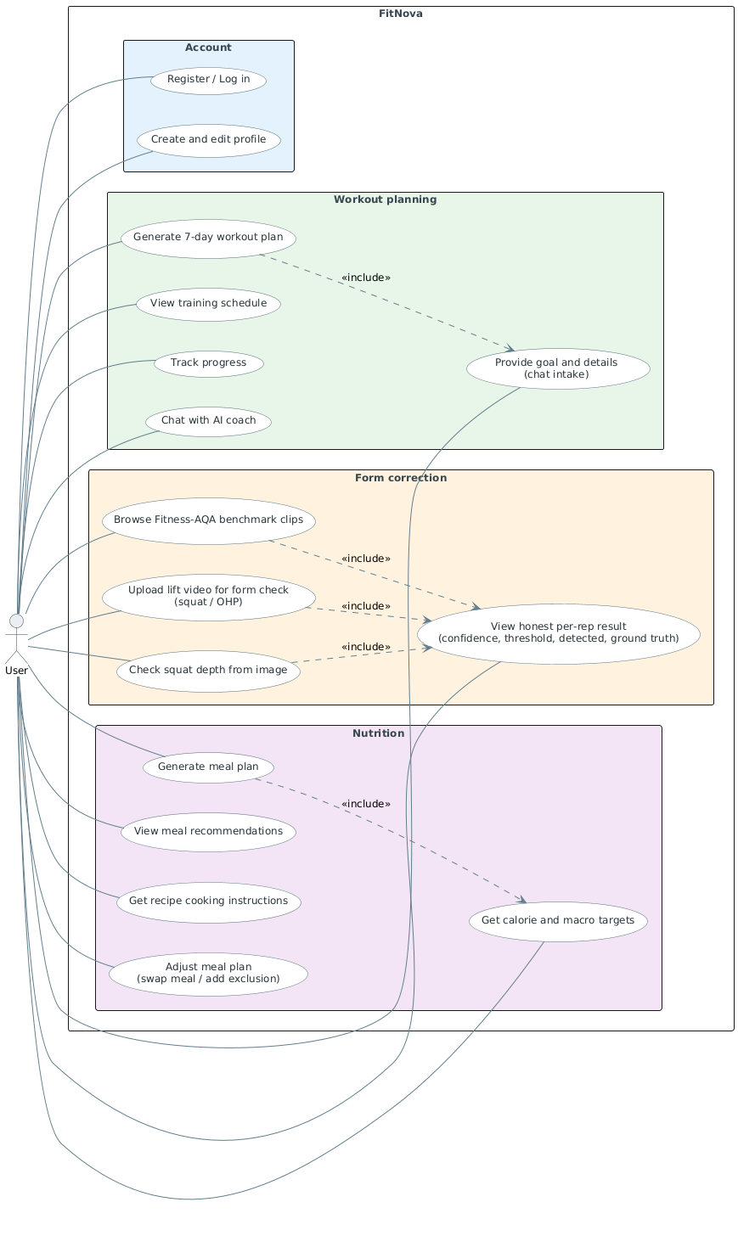
The use cases fall into a small account layer and the three modules. In the account layer the user registers, logs in, and creates the profile that the planning and coaching features read from. In planning the user sets a goal, generates a seven-day plan, views the schedule, marks exercises and days as done, and can talk to an AI coach. In form correction the user uploads a lift or opens a benchmark clip and reads the honest per-repetition result. In nutrition the user gets calorie and macronutrient targets, generates a meal plan, reads the recommendations, asks for cooking instructions, and can adjust the plan. Everything passes through one backend, and nothing here needs the three modules to talk to each other, which matches the loosely-coupled design of Section 3.1.
The functional requirements run from the account layer outward, because every other feature reads the profile it produces. The user registers, logs in, and creates a profile that holds the training and body details the rest of the system needs. That profile is gathered in two ways that suit different users. A direct form lets a user fill in the fields, and a conversational intake lets a user describe their training in plain language, from which the system pulls out the three parameters the recommender needs most, the experience level, the session length, and the weekly frequency. The two paths meet in the same profile, so a user can begin with a short chat and never open a form.
Planning is the first feature built on that profile. The user asks for a seven-day plan, and the system has to produce one that fits the profile and, above everything, the stated goal, so that a plan for losing weight and a plan for gaining muscle come out clearly different. The plan has to be made only of real exercises from the dataset, and it has to be checked against the user's available training days, their equipment, and any injuries they listed, so that what comes back is always something the user can actually do safely. Around the single plan, the user can read the schedule day by day, mark exercises and whole days complete so the app tracks the week's progress, and hold a conversation with an AI coach that answers questions and, when asked, starts a fresh plan from the details it has gathered.
Form correction has the plainest contract of the three, and that is deliberate. The user uploads a squat or an overhead-press video, or opens a squat-depth image, and the system returns, for each repetition it finds, the raw confidence for every named error, the threshold that confidence is judged against, and whether the error was detected, along with a thumbnail of the repetition and a count of repetitions. There are no severity words and no coaching sentences, because the dataset labels are yes or no and anything richer would be made up. The same feature lets the user open the dataset's own benchmark clips and see the model's output set against the expert ground truth, which turns a feature that would otherwise have to be trusted into one that can be checked. And because the models only hold up on footage like their training data, the feature has to warn the user when a clip falls outside that domain and steer them toward a side-on, full-body, landscape shot.
Nutrition mirrors planning, but for food. From the profile the system computes a calorie target and a split into protein, fat, and carbohydrate, then builds a meal plan from real recipes that meets those numbers and respects the user's diet and allergies. The plan carries a guarantee that its totals land on target and that no excluded ingredient is present, and only after that does the system add a readable explanation, a name and a short theme for each day taken from the actual recipes, a quality note, and a few practical tips. The user can ask for full step-by-step cooking instructions for any recipe, and can adjust a finished plan by swapping a meal or adding an ingredient to avoid, with the change carried out by the deterministic planner so the plan stays correct after the edit.
All of this reaches the user through one backend, which exposes the features over ordinary request-and-response calls, a streaming channel for the progressive and live parts, and a websocket for the live camera path, and which also serves the media the features need. Table 3 collects these behaviours as numbered requirements for reference.
Table 3 - Functional Requirements
ID | Requirement | Area
FR-1 | Register, log in, and create a stored user profile | Account
FR-2 | Set a fitness goal and give profile data through a form and a conversational intake that extracts experience level, session length, and weekly frequency | Account
FR-3 | Generate a personalized seven-day workout plan from the profile with the layered recommender, using only real exercises from the dataset | Planning
FR-4 | Match the plan to the stated goal and validate it against the user's training days, equipment, and injuries | Planning
FR-5 | View the training schedule and track progress by marking exercises and days complete | Planning
FR-6 | Upload a squat or overhead-press video, or select a squat-depth image, and get a per-error result (confidence, threshold, detected) for each repetition | Planning
FR-7 | View a squat or overhead-press video, or select a squat-depth image, and get a per-error result (confidence, threshold, detected) | Form
FR-8 | Show each form result beside the Fitness-AQA benchmark ground truth, with a rep thumbnail and a rep count, and with no severity words or coaching sentences | Form
FR-9 | Stream camera frames live and return per-repetition feedback as a repetition ends | Form
FR-10 | Surface the domain-shift caveat and framing guidance for casual video | Form
FR-11 | Compute calorie and macronutrient targets from the profile | Nutrition
FR-12 | Build a meal plan from real Food.com recipes that meets the targets and respects diet and allergies, with a verified-correct guarantee | Nutrition
FR-13 | Annotate the meal plan with a plain-language explanation, day themes, a quality note, and tips, without changing any number or food | Nutrition
FR-14 | Generate step-by-step cooking instructions for a recipe on request | Nutrition
FR-15 | Modify a plan by swapping a meal or adding an exclusion, with the change applied deterministically so the plan stays correct | Nutrition
FR-16 | Serve all features through one backend over REST, WebSocket, and server-sent events, including media | Platform

The behaviours above are only worth anything if they hold to a set of qualities, and this is where most of the project's character sits. The first and most important quality is that the system does not fabricate. This is built into the structure of every module rather than being a matter of tone or a guideline to follow. In planning, the language model crew may only assemble a plan from a pool of real exercises, and a deterministic validator drops anything outside that pool, so an invented movement can not reach the user. In nutrition, every number comes from a fixed formula and every recipe is chosen by a deterministic selector and re-checked by a verifier before any language model is allowed to speak, so a wrong calorie total, or a recipe that was never in the dataset, is impossible by construction. In form correction, the services hand back a measured probability and a threshold and nothing else, so there is no opening for an invented verdict. The whole system is arranged so that the parts which could make something up are kept away from the parts that decide anything.
The second quality is evaluation fidelity. Every number this report puts forward about model quality is computed on the official train, validation, and test split of the dataset it belongs to, with the same metric the source work used, and it can be reproduced from a result file kept in the repository. This matters because the project's central claim is a comparison with published work, and a comparison only carries weight when it is measured the same way and can be repeated.
The third quality is performance good enough to feel interactive. The form models run a small ensemble for each repetition, and the squat path was also exported to a faster runtime so that a single repetition is scored in roughly a second; the heavier plan generation runs in its own process under a time limit; and because the backend sits on a single event loop, the heavy model calls are pushed onto a worker thread so that one user's inference does not freeze the server for everyone else.
The fourth quality is graceful degradation. A missing model file, or a missing key for the language models, has to leave the system working rather than crashing. When the form weights are absent the service returns a neutral, clearly marked result; when there is no language-model key the planning and nutrition features fall back to deterministic template explanations that still carry the correct numbers; and every live session is given its own isolated state so that one user's stream can not disturb another's.
The fifth quality is honesty about the limits, which is an unusual thing to write into a requirement but is central here. The form models are trained on one kind of in-the-wild footage and are close to random on a casual front-facing phone clip, and the system is required to say this plainly, to mark input that falls outside that domain, and never to dress a weak result up as a confident one.
The remaining qualities are more ordinary but still required. The user's data endpoints are protected by authentication and the media endpoint is guarded against path traversal. The scope stays non-clinical, and allergens are removed by construction rather than by warning. The model directories and the ensemble sizes can be set from the environment, so the system moves between machines without code changes. The datasets are used within their research and licensing terms. And a single source of truth for preprocessing keeps the served model identical to the one that was trained, which is the strongest guard against a model that scores well in an evaluation and then behaves differently once it is deployed. Table 4 collects these as numbered requirements.
Table 4 - Non-functional Requirements
ID | Requirement
NFR-1 | No fabrication: the system never presents an invented exercise, number, or recipe; correctness is enforced by deterministic gates before any language model runs (strictly from the datasets).
NFR-2 | Evaluation fidelity: every reported metric uses the source work's own metric on the dataset's official split and is reproducible from a committed result file
NFR-3 | Limitations: the form feature states that the models are reliable only on in-the-wild dataset footage and weak on casual phone video
NFR-4 | Safety and security: user-data endpoints are authenticated, media access is protected against path traversal

Design / Simulation set up
This section gives the detailed design of the system. It first describes the platform as a stack of layers, then walks down the design and the data flow of each of the three pipelines, with a figure for each, and ends with the backend that ties them together and the data and the models that sit behind them.
FitNova is built as four layers stacked on each other. At the top is the client, a mobile application that collects the user's input and shows the results. Below it is the backend, a single service that receives every request and routes it to the module it belongs to. Below that is the service layer, the recommender, form, and nutrition code, which is loaded once when the backend starts and then kept in memory for the life of the process, so that no model is read from disk on a per-request basis. At the bottom is the data and model layer, the datasets, the trained model files, and the cleaned catalogues, which the services read from but never change while the system is running. The overall shape of this stack was given in Figure 2, and the design below fills in the two middle layers, the backend and the services.
The workout planner has the most clearly layered design in the system, and Figure 4 draws it from the user profile at the top down to the finished plan at the bottom. The figure is worth reading before the description, because the vertical order of its boxes is exactly the order in which a request passes through the pipeline.
Figure 4 - Workout-plan recommender pipeline
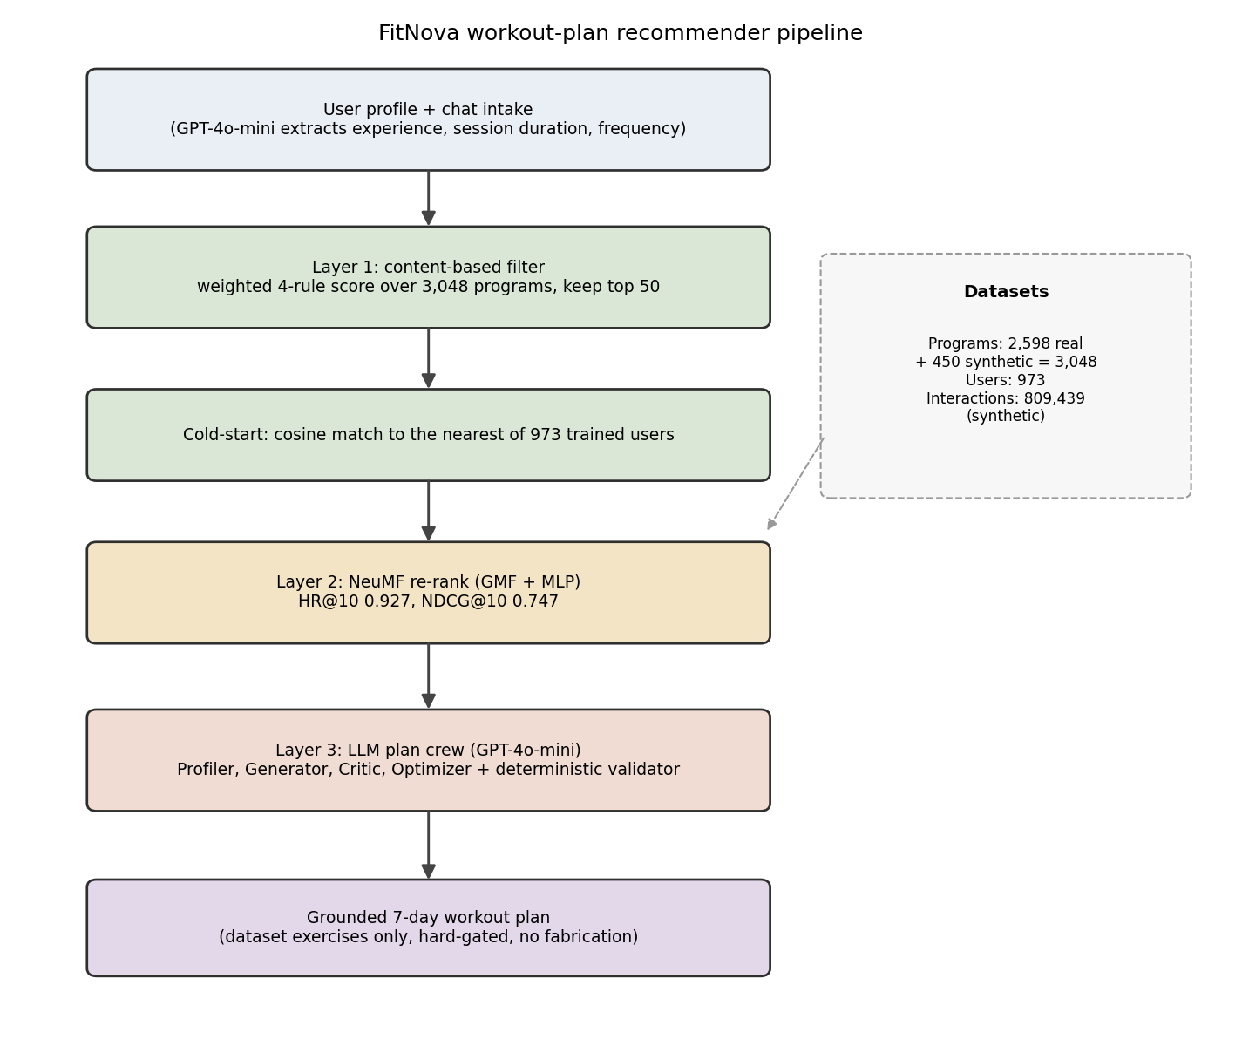
The flow begins with the user profile, with the conversational intake filling in the three parameters it can extract, the experience level, the session length, and the weekly frequency. The first layer is a content-based filter that scores every one of the 3,048 programs in the catalogue with a weighted four-rule score and keeps the fifty that fit the profile best. The second layer is the learned one, and the cold-start box in front of it solves the problem that a new user is unknown to a collaborative model: the system finds the nearest of the 973 known users by cosine similarity and borrows that identity, then the Neural Collaborative Filtering model re-ranks the fifty candidates for it [2]. The blended score that comes out of this layer mixes the learned score, the content score, and the user's intent, with the intent kept as the strongest signal so the plan never drifts off the user's goal. The third layer hands the chosen program to the language model crew and the deterministic validator described in Section 3.1, and the pipeline ends in a plan made only of real dataset exercises. The panel on the right of the figure lists the data behind all of this, the 2,598 real and 450 synthetic programs, the 973 users, and the 809,439 synthetic interactions that the model in the second layer was trained on, with the arrow into that layer making the dependency clear.
The form-correction module is built from two models, one for each of the two kinds of input it has to read, and Figure 5 shows the two methods side by side. The left branch is for the errors that only make sense in motion, and the right branch is for the one error that can be read from a single still frame.
Figure 5 - Form-error detection, two-method architecture
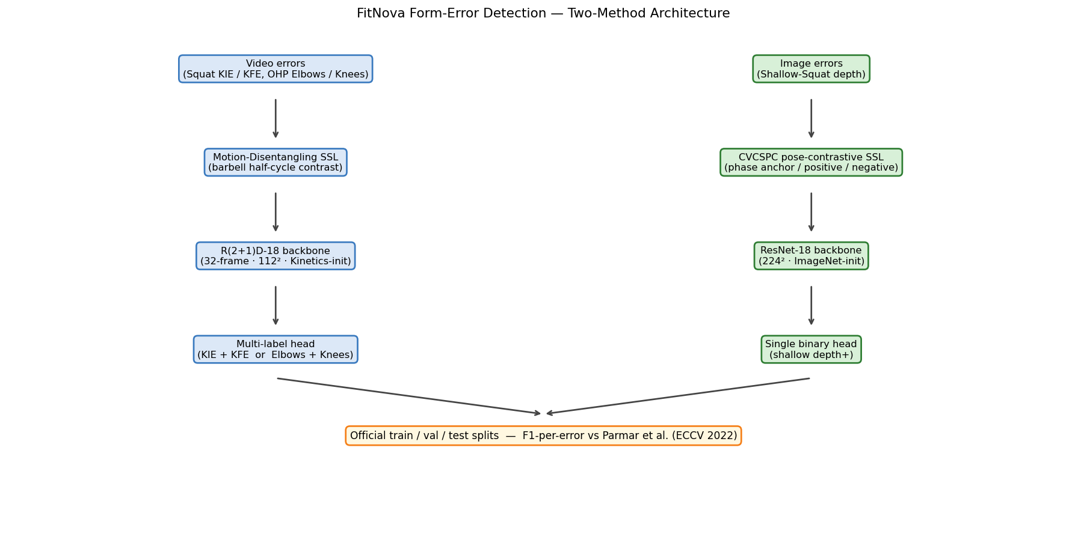

On the left, the video errors, the two squat errors and the two overhead-press errors, are handled by a Motion-Disentangling self-supervised stage that learns from the structure of the barbell's path through a repetition, feeding an R(2+1)D-18 backbone that reads thirty-two frames at a time and ending in a multi-label head that reports the two co-occurring errors of each exercise together [3], [11]. On the right, the single depth error of a squat is handled by a Cross-View Cross-Subject pose-contrastive stage feeding a ResNet-18 image backbone and a single binary head [10], [25]. Both branches meet at the bottom of the figure at the same place, the dataset's official train, validation, and test splits, where each is scored with the per-error F1 against Parmar et al. The design at serving time follows the same split. A recorded clip is decoded to thirty-two evenly spaced frames, cropped and normalised exactly as the network was trained, then passed through a small ensemble of separately trained models whose probabilities are averaged, and each error is reported only when its averaged probability clears the threshold tuned on the validation data. A whole uploaded clip is treated as a single repetition, which fits the way the dataset was collected, while the live camera path adds a light motion-energy step that watches the movement with no pose estimate and fires the same models when a repetition ends. The benchmark inspector reuses these services unchanged and simply runs them on the dataset's own test clips so the output can be placed beside the expert ground truth.
The nutrition module is designed as a deterministic core wrapped in a thin language layer, and its data flow, drawn in Figure 6, is the clearest single picture of the no-fabrication principle in the whole system.
Figure 6 - Nutrition pipeline data flow
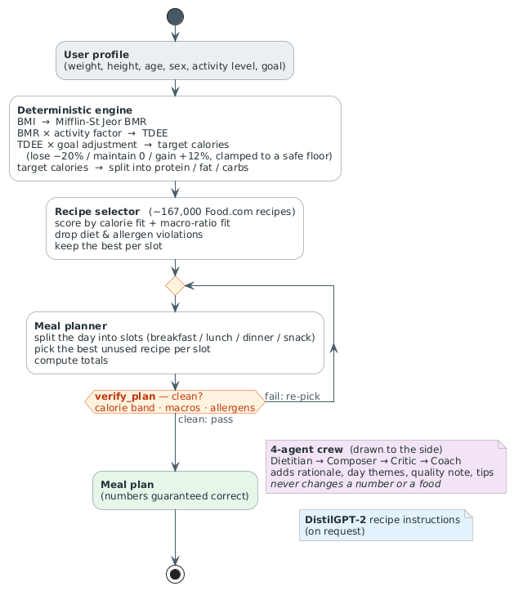
Reading the figure from top to bottom, the user's body details and goal enter a deterministic engine that computes a resting metabolic rate with the Mifflin-St Jeor equation, scales it by an activity factor into a daily energy need, adjusts it for the goal, and splits it into protein, fat, and carbohydrate targets [14]. A selector then searches the cleaned pool of about 167,000 Food.com recipes and scores each one on how well it fits the calorie target and the macro ratio, while removing anything that breaks a diet rule or contains an excluded ingredient [4]. A planner places the chosen recipes into the slots of a day, or a week, and then a verify step re-checks the whole plan against the calorie band, the macro targets, and the allergen list. This verify step is drawn as a gate, because it is the point at which correctness is guaranteed: only a plan that passes it is allowed through. Only after the gate does the four-agent crew add its explanation, its day themes, its quality note, and its tips, and the figure draws the crew to the side of the main line on purpose, because it annotates a plan that is already settled and can not change a number or a food.
All three pipelines live inside one backend, and its design has to hold several things together at once. When the backend starts it loads every service one time and attaches it to a shared application state, so the recommender, the language adapters, the three form services, the nutrition crew, and the benchmark catalogue are each built once and then reused. The backend speaks three transports: ordinary request-and-response calls for the stateless features like generating a plan or computing nutrition targets, a server-sent event stream for the features that report progress as the agent crews work, and a websocket for the live camera path, where each connection is given its own isolated session so that one user's stream of frames can not mix with another's. Two machine-learning runtimes run inside the same process, because the form models are in PyTorch and the existing recommender is in TensorFlow, and the backend is designed to load both without either interfering with the other. One part is deliberately pushed out of the main process: the workout-plan crew runs in a separate, isolated environment and is reached through a short-lived subprocess, which keeps the heavy agent framework and its dependencies away from the rest of the backend, while the lighter nutrition crew runs in the main process directly. Because the whole server runs on a single asynchronous event loop, the model calls, which are the slow part, are pushed onto worker threads so that one user's inference does not block everyone else's requests.
Behind the services sits the data and model layer, which is read-only while the system runs. The planner reads a catalogue of 3,048 programs and a trained Neural Collaborative Filtering model with its two pretrained component models, together with the normalisation statistics used to encode a profile. The form module reads three small sets of trained weights, one for each exercise family, with the squat set also exported to a faster runtime for quicker inference. The nutrition module reads the cleaned pool of about 167,000 recipes and the small distilled language model that writes cooking instructions on request. None of these files is written during a request, which is part of why the same input always produces the same output and why the system can be reasoned about and tested. The implementation of each of these pieces, the datasets and how they were prepared, the exact model architectures, and the training that produced the weight files, is the subject of the next chapter.

Implementation
This chapter is the concrete build of the three pipelines, where the design of Chapter 3 turns into datasets, model code, training runs, and serving. It is the longest chapter, and it is organised pipeline by pipeline. This section covers the fitness planning pipeline. The form correction pipeline follows, together with an honest account of the earlier designs that were built on other datasets and then dropped, and the nutrition pipeline comes last. The stack is shared across the three: the recommender model is in TensorFlow, the form models are in PyTorch, the language parts use a hosted GPT-4o-mini model through small agent crews, a small distilled language model writes recipe text, and everything is served from one FastAPI backend. Every number reported in this chapter is taken from a result file kept in the repository, so the figures can be reproduced rather than taken on trust.

Fitness Planning Pipeline
The fitness planning pipeline is the three-layer recommender of Section 3.3, and this section describes how it is built. It starts with the data, then takes each of the three layers in turn: the content-based filter, the neural collaborative filtering model, and the language model crew that writes the final plan.

Datasets
The recommender is built on two public Kaggle datasets and a third set of interactions that the project generated itself. The first dataset is a fitness-program dataset in which each row is a single exercise inside a named program. The build step groups these exercise rows by program title, so every unique title becomes one program record carrying its training goal, its difficulty level, its program type, and the full list of its exercises by week and day. The difficulty of a program is taken as the easiest level it lists, and its type, whether it is mainly strength, cardio, yoga, or interval training, is inferred from keywords in the title and the exercise names. This collapse produces 2,598 real programs.
Because those real programs lean heavily toward strength training, the catalogue is padded with 450 synthetic programs, 150 each of yoga, cardio, and interval training, so the minority types are represented well enough for a model to learn them. The final catalogue is 3,048 programs, 2,598 real and 450 synthetic.
Figure 7 - Programs catalogue EDA
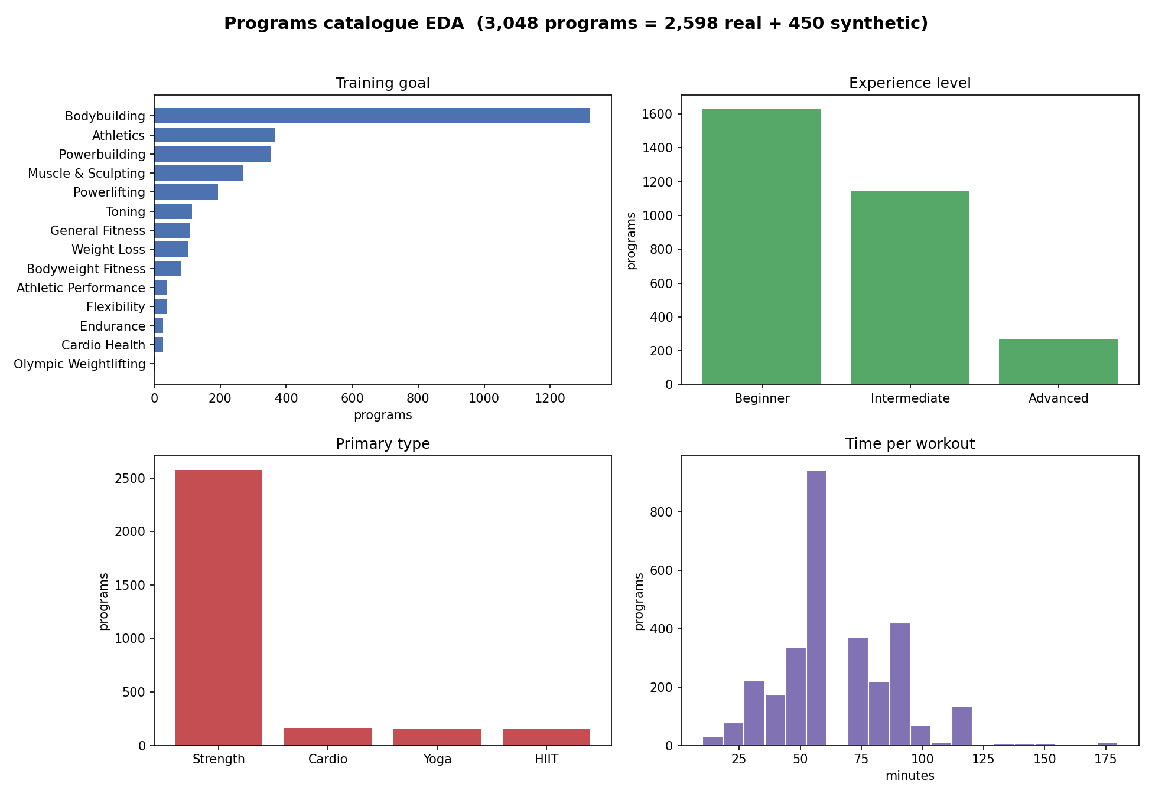
Figure 7 shows the make-up of this catalogue. The training-goal panel shows how strongly the real data leans toward bodybuilding and the strength goals, with the lighter goals like flexibility and cardio health appearing only a few dozen times each. The experience-level panel shows the catalogue weighted toward beginner and intermediate programs, and the program-type panel shows the effect of the synthetic padding, with strength still dominant but yoga, cardio, and interval training each now clearly present. The time-per-workout panel shows most programs sitting between 40 and 90 minutes. This imbalance is the reason the interaction data and the way the model is evaluated were handled with care.
The second dataset is a gym-members dataset of 973 people, each described by age, sex, height, weight, body-mass index, the length of a typical session, how many days a week they train, their main workout type, and an experience level. This is the dataset the recommender treats as its set of known users.
Figure 8 - Gym-members dataset EDA
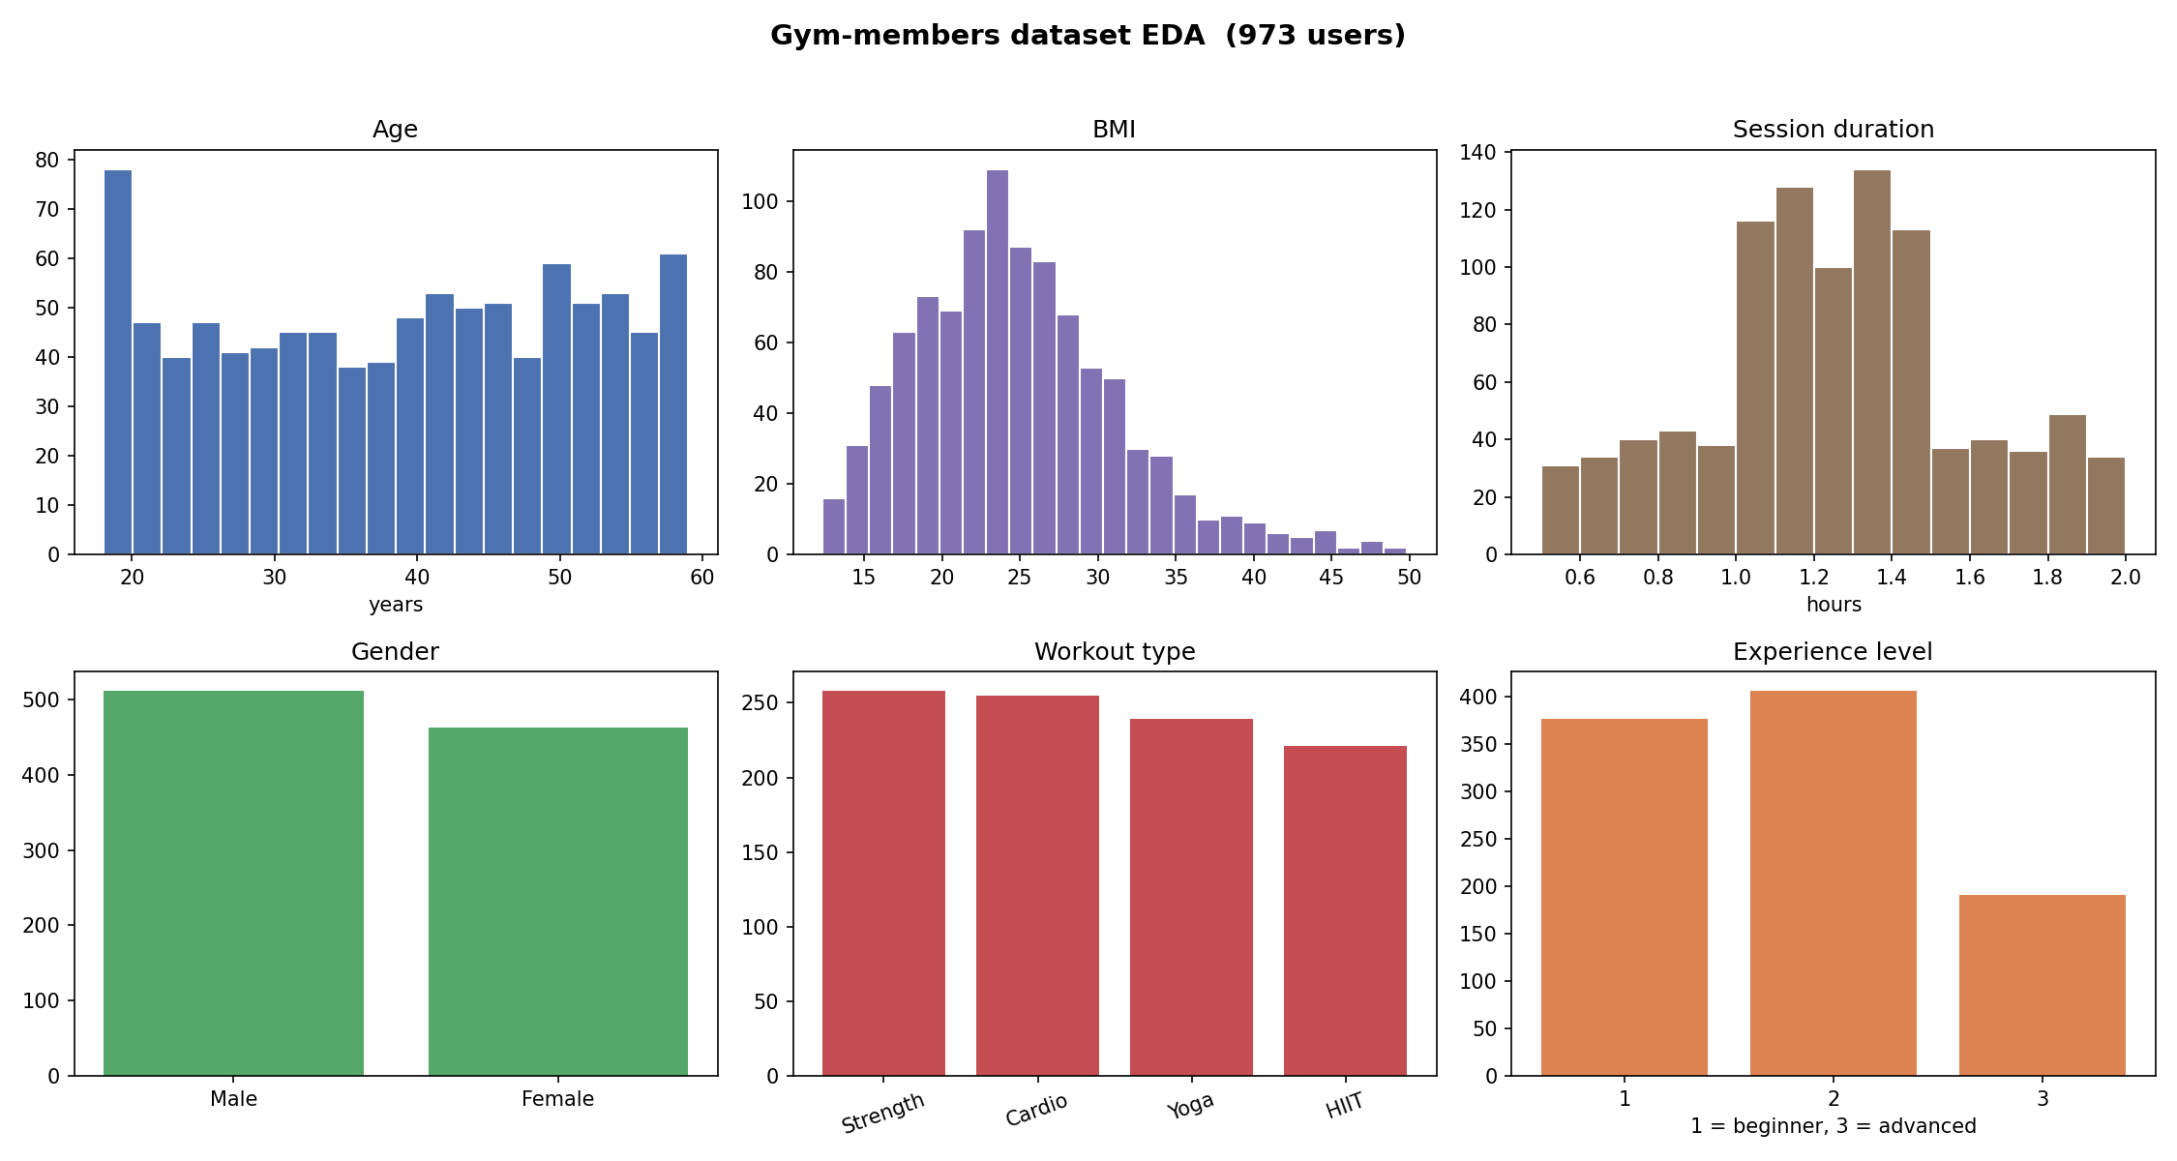
Figure 8 shows the spread of these members. They run from 18 to 59 years old with a mild concentration in the early twenties, the body-mass index is centred a little under 25 with a long tail upward, the two sexes are close to even, and the four workout types and three experience levels are all well represented. There is nothing unusual in the distribution, which makes it a reasonable basis for the cold-start matching described later.
The third set is the one that has to be described carefully, because it is not real. A collaborative filtering model needs a record of which users liked which items, and no such record exists for this project, since there is no deployed app collecting real choices. The interactions were therefore generated. For each of the 973 users and each of the 3,048 programs, a compatibility score is computed from a weighted rule, leaning mostly on how well the program's type matches the user's preferred type, with smaller contributions from experience, session length, and weekly frequency, and a small amount of random noise is added. The scored matrix is then turned into yes-or-no interactions by choosing a cut-off that leaves the matrix about 94 to 96 percent empty, the kind of sparsity a real recommendation dataset has, and four negative examples are sampled for every positive one. The result is 809,439 interactions, of which 161,948 are positive, at 94.5 percent sparsity.
Figure 9 - Synthetic user-program interactions EDA
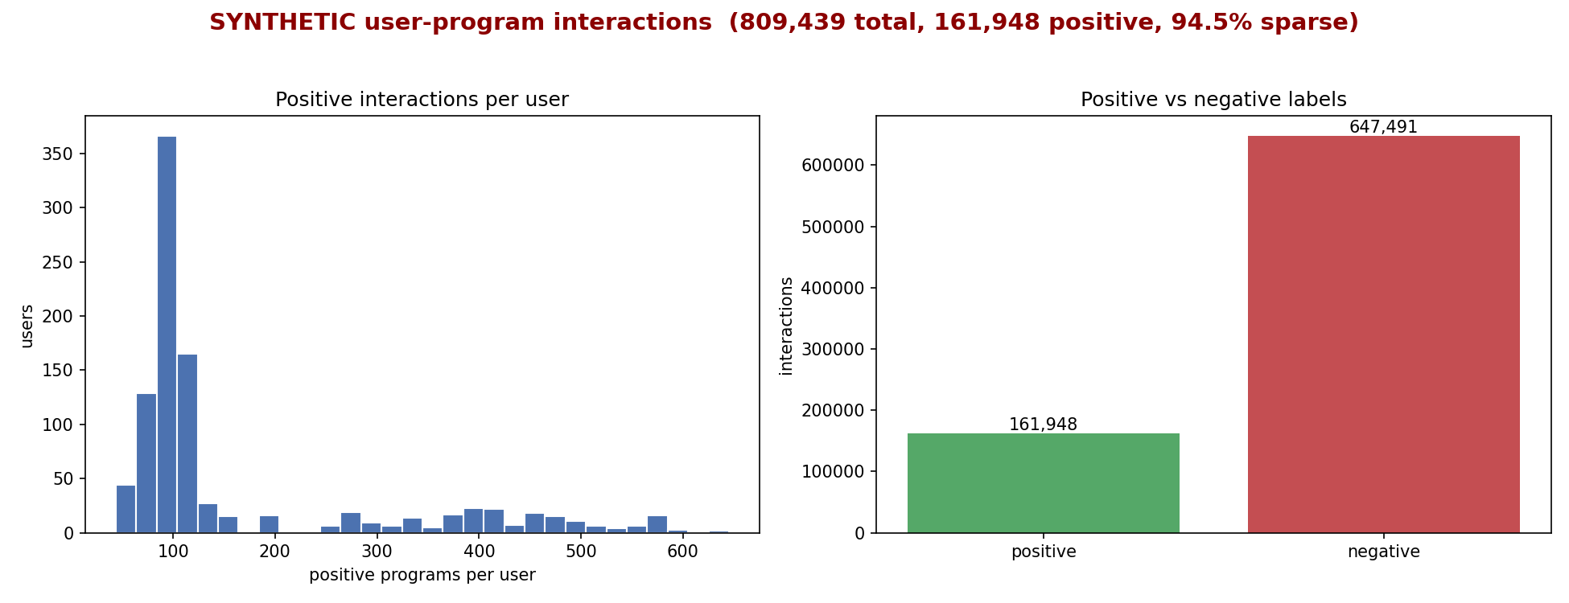
Figure 9 shows this generated data, and it is labelled synthetic on its face for the same reason it has to be flagged here. Because the interactions were produced from a rule, a model trained on them is, at best, learning to reproduce that rule. The hit-rate and ranking scores reported in Chapter 6 measure how well the neural model reconstructs the synthetic compatibility pattern, which is a fair test of the modelling method but is not evidence about real-world recommendation quality, which would need real user behaviour to judge. One detail matters for honesty: the weights used to generate the interactions, which lean heavily on workout type, are deliberately not the same as the weights the serve-time content filter uses, which lean on experience, so the learned model is not simply handed the exact rule the first layer already applies.

Layer 1: Content-based Filtering
The first layer scores every program in the catalogue against the user profile with a weighted sum of four rules: how well the program's difficulty matches the user's experience, weighted 0.35; how well its type matches the user's preferred type, weighted 0.30; how close its session length is to the user's, weighted 0.20; and how close its weekly frequency is, weighted 0.15. Each rule is a small lookup or a banded score rather than a raw difference, so a near match scores well and a far one scores zero. On top of the weighted sum, a tie-breaker rewards a program whose goal exactly matches the user's stated intent, which keeps the goal visible even when two programs otherwise score alike. The 50 highest-scoring programs are passed to the next layer. This kind of additive content-based scoring follows the content-based recommender tradition [7]; the exact weights are the project's own choice rather than a published formula.

Layer 2: Neural Collaborative Filtering
The second layer is a Neural Collaborative Filtering model, built as He et al. describe it [2] and implemented in TensorFlow [30]. It has two halves. One half, generalised matrix factorisation, gives each user and each program a 16-dimensional vector and multiplies them element by element, which is the neural form of classic matrix factorisation [8]. The other half, a multi-layer perceptron, gives each user and each program a separate 32-dimensional vector, joins them, and passes them through a tower of fully connected layers of sizes 64, 32, 16, and 8. The two halves are joined at the end, the 16-dimensional product from the first and the 8-dimensional output from the second, and a single unit reads a score from the combined 24 numbers.
The model is trained in the three stages the original method prescribes. The two halves are first trained on their own, each for 20 passes over the data with the Adam optimiser, then their learned weights are copied into the combined model, whose final layer is started as a balanced mix of the two, and the whole model is fine-tuned for 10 more passes with plain stochastic gradient descent, keeping the version that scored best along the way. It is evaluated the way the original paper evaluates it, by holding out one positive program per user and ranking it against 99 programs the user did not interact with, then measuring how often the held-out program lands in the top 10, the hit rate, and how high it sits when it does, the normalised discounted cumulative gain. On this test the combined model reaches a hit rate at 10 of 0.9270 and a ranking score of 0.7469, ahead of either half on its own, and the full comparison is shown in Chapter 6. These numbers carry the caveat from the data section: they show the method works on the data it was given, and that data is synthetic.
At serving time a new user, who is not one of the 973 known users, is first mapped to the nearest known user by cosine similarity over the profile, so the model has an identity to score with. The model's score for each of the 50 candidates is then blended with the content score and the user's intent, weighted 0.45 to the model, 0.25 to the content score, and 0.30 to the intent, and the intent is also used as a hard tier, so a program that matches the user's goal always outranks one that does not, whatever the blended score.

Layer 3: Plan Assembly and Validation
The third layer turns the single chosen program into a written seven-day plan. Before this, the user's three core parameters can be gathered through a short conversation: the hosted GPT-4o-mini model reads the user's messages and pulls out the experience level, the session length, and the weekly frequency, and reports the intake as finished only once all three are present. The plan itself is written by a crew of four agents on the same model, a Profiler that reads the profile, a Generator that drafts the plan, a Critic that judges it, and an Optimizer that fixes it. The crew is given a pool of exercises taken only from the chosen program, topped up where a training split needs a movement group the program is short on, but never with anything from outside the dataset. The Critic and the Optimizer loop for up to three rounds, and the loop stops as soon as a deterministic check reports no hard violations.
That deterministic check is the real guarantee. It counts a violation whenever the plan has the wrong number of training days, places an exercise on a day its movement group does not belong to, asks for equipment the user does not have, or includes a movement that clashes with a listed injury, and it repairs these by dropping or replacing the offending exercise from the dataset pool. The Critic's own score is capped by this count, so the language model can not award a high score to a plan that still breaks a rule. The crew is built with CrewAI, a framework for orchestrating several language model agents in sequence, and it runs in a separate, isolated environment reached through a short-lived subprocess, which keeps that framework's heavy dependencies away from the rest of the backend. If the language model is unavailable, a deterministic template still produces a valid plan from the same pool. The plan that reaches the user is therefore always made of real dataset exercises and always passes the rules.

Form Correction Pipeline
The form correction pipeline is the deepest technical work in the project, and it was rebuilt from the ground up on the Fitness-AQA dataset and method after the earlier designs described at the end of this section were dropped. It detects five named errors across three exercises: in the squat, the knees caving inward and the knees travelling too far forward; in the overhead press, the elbows flaring and the knees bending; and, from a single image, a squat that does not reach depth. The four motion errors are read from video by a three-dimensional convolutional network, and the depth error is read from a still frame by an image network. This section follows the build in the order it was done: the dataset and what is in it, the supervised baseline, the self-supervised pretraining that improves it, the image model, the ensembles and serving, and finally an honest account of the approaches that were tried first and rejected.

Dataset and exploratory analysis
The dataset is Fitness-AQA, the in-the-wild gym dataset of Parmar et al. [3]. Its clips were collected from public video platforms and show real people training in real gyms, with all the camera angles, clothing, lighting, and partial occlusion that this implies, and each clip is annotated by expert trainers for the specific errors it contains. The project uses the dataset's three exercises, the back squat, the overhead press, and the squat seen as a still image, with the official train, validation, and test splits taken exactly as released, so that every number can be compared straight against the published work.
The table below sets out the five errors and how they break down. Two things stand out. The first is how rare some errors are: the inward-knee squat error is present in only about one clip in seven, and the elbow error in the overhead press in about one in four, while the forward-knee squat error is the opposite and shows up in two clips out of every three. A detector therefore has to find a needle for some errors and a haystack for others, which is exactly why the decision thresholds are tuned per error rather than left at one half. The second is that, in the squat, the two errors travel together: of the 232 clips with the inward-knee error, 192 also have the forward-knee error. Because they co-occur this strongly, the two squat errors are learned by one shared network with a two-output head rather than by two separate models.
Table 5 - Fitness-AQA errors used in FitNova, with class balance and official splits.
Error | Modality | Total | Erroneous (%) | Train / Val / Test
Squat knees-inward (KIE) | video | 1,623 | 232 (14.29%) | 1,136 / 243 / 244
Squat knees-forward (KFE) | video | 1,623 | 1,109 (68.33%) | 1,136 / 243 / 244
Squat shallow-depth | image | 3,611 | 1,584 (43.87%) | 2,542 / 529 / 540
OHP elbows | video | 2,260 | 576 (25.49%) | 1,582 / 339 / 339
OHP knees | video | 2,260 | 777 (34.38%) | 1,582 / 339 / 339

The video clips run at 30 frames per second and vary a good deal in length, the squat clips from 49 to 404 frames with a median around 111, and the overhead-press clips from 49 to 271 with a median around 107, so each one is later reduced to a fixed number of frames before it reaches a model. Alongside the small labelled sets, the dataset provides much larger pools of unlabelled clips, several thousand for each exercise, and these are what the self-supervised pretraining described shortly learns from.
Figure 10 - Fitness-AQA error class balance and the squat KIE/KFE co-occurrence.
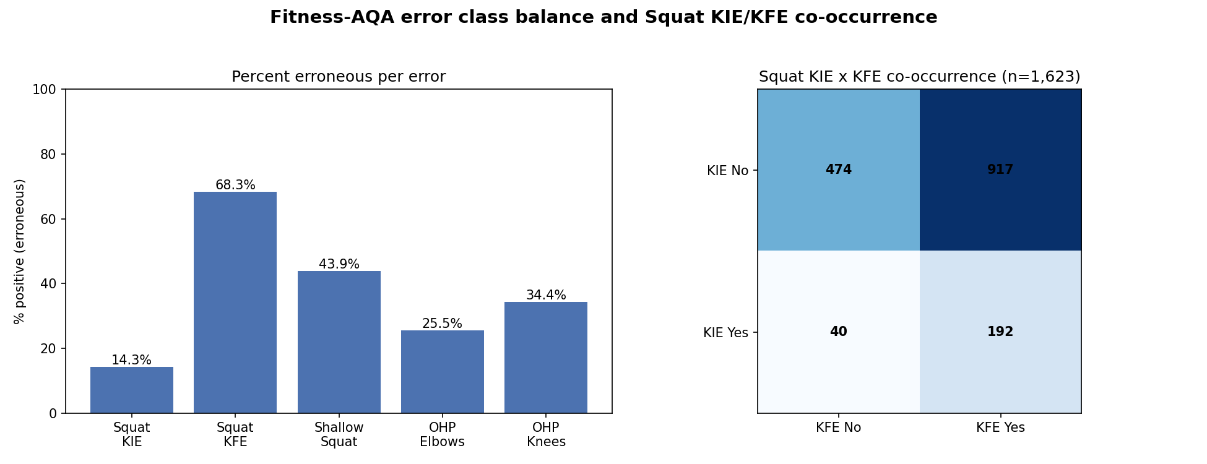
The left panel shows the percentage of erroneous examples for each error, making the gap between the rare inward-knee error and the common forward-knee error plain to see, and the right panel is the two-by-two table of how the two squat errors fall together, with the 192 jointly erroneous clips filling the bottom-right corner. The imbalance and the co-occurrence in this figure are the two facts that shaped the model design.
Because this imbalance runs through every error, the module handles it in a few specific ways rather than letting the rare errors be ignored. The training loss is class-weighted, so a positive example of a rare error counts for far more than a positive of a common one; for the squat, where the inward-knee error is rare and the forward-knee error common, the two weights work out at about 6.1 and 0.45, roughly the inverse of how often each error appears. The decision threshold for each error is then chosen on the validation split alone, never on the test split, so a scarce error is not lost simply because a default cut-off of one half happens to suit the common case. The self-supervised pretraining covered later in this section lifts the rarest errors the most, which is where a few hundred labels help least. And the final model for each exercise is a small ensemble of networks trained from different random seeds, whose averaged output is steadier on the rare classes than any single run. Together these keep the scarce errors visible instead of being swallowed by the common ones.

The Supervised Baseline
Following the project's data-first principle, a plain supervised model was trained for each exercise before any self-supervised pretraining, so that the value of the pretraining could later be reported as a measured gain over a real baseline. The model is an R(2+1)D-18 network [11], implemented in PyTorch [31]: a residual 18-layer three-dimensional convolutional network that splits each spatio-temporal convolution into a spatial convolution followed by a temporal one, started from weights pretrained on the Kinetics-400 action-recognition dataset [32]. Each clip is reduced to 32 frames sampled evenly across its length, every frame resized so its short side is 128 pixels and then centre-cropped to 112 by 112 and normalised with the Kinetics statistics, which is exactly the input the backbone was trained on. Because the two squat errors co-occur, they share one backbone with a two-output multi-label head rather than two separate models, and the strong class imbalance is handled with a class-weighted loss that gives the rare positive examples more weight.
Trained this way, the squat baseline reaches a test F1 of 0.286 on the rare inward-knee error and 0.800 on the common forward-knee error, a macro average of 0.543, which already lands within about two percent of the published supervised result. But it overfits the small labelled set badly: over training the training loss falls from 0.83 to 0.07 while the validation loss climbs from 0.81 to 2.27, the plain signature of a model that has memorised a few hundred positive examples rather than learned the error. The overhead-press baseline behaves the same way. This overfitting, and not a hunch, is the concrete reason the project turned to the self-supervised pretraining described next, which gives the network a head start that a few hundred labels can not.

Motion-Disentangling self-supervised pretraining
The fix for the baseline's overfitting is to give the network a useful starting point that does not depend on the few hundred labels, and that is what self-supervised pretraining provides. The method is the Motion-Disentangling task of Parmar et al. [3], a contrastive task that learns from the large pool of unlabelled clips with no error labels at all. It uses a piece of gym-specific domain knowledge: a repetition has a clear lowest point, the bottom of the squat or the bottom of the press, which can be found from the barbell's path with no human labelling, and each repetition is split there into two halves. The network is then trained, in the contrastive way that methods like SimCLR made standard [25], to pull together the representations that belong to the same repetition and push apart those from different ones, so that it learns what the motion of a real lift looks like before it is ever shown a labelled error.
The pretraining is sensitive to how the input is augmented, and getting that wrong makes it collapse, which is worth recording because the fix is instructive. With a mild set of augmentations the representations lose their variety, a measure of their effective spread falling from about 11.8 to 3.3, and a quick test that trains a simple classifier on the frozen features peaks at the fifth epoch and then gets worse, the tell-tale sign that the network has found a shortcut instead of learning the motion. The cure is to follow the paper's own recipe more closely and use a stronger set of augmentations, with one deliberate exception: rotation is left switched off, because rotating the frame would change the very knee angle that the inward-knee error depends on, and a task that learns to ignore rotation would also learn to ignore that error. With the stronger augmentations the collapse goes away. On the frozen features the simple classifier now reaches a macro score of about 0.57 against 0.43 for the plain Kinetics start, a gain of about 0.14, and almost all of that gain sits on the rare inward-knee error, whose score roughly doubles, which is exactly the error that a few hundred labels struggle with most.
Figure 11 - Motion-Disentangling pretraining health
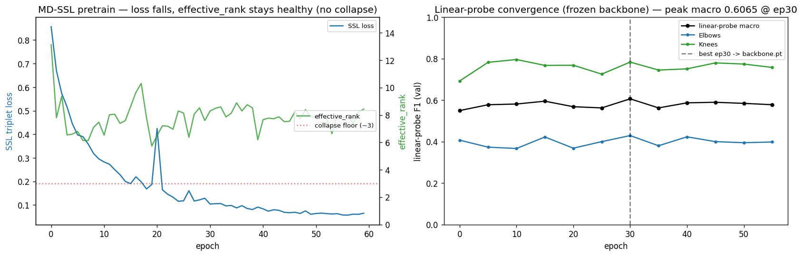
Figure 11 shows a healthy pretraining run, here for the overhead press. The contrastive loss falls smoothly, the measure of representation spread stays well above the collapse floor instead of sliding toward it, and the frozen-feature classifier climbs and then holds rather than peaking and dropping, all three the opposite of the collapse just described.
After pretraining, the network is fine-tuned on the small labelled set in the ordinary supervised way, but it now starts from features that already understand the movement. A single fine-tuned network still overfits eventually, so the run keeps the version from the epoch just before the validation loss starts to rise rather than the final one, and the deployed model for each exercise is a small ensemble of these fine-tuned networks trained from different random seeds, three for the squat and two for the overhead press, whose probabilities are averaged.
Figure 12 - Fine-tuning with early stopping
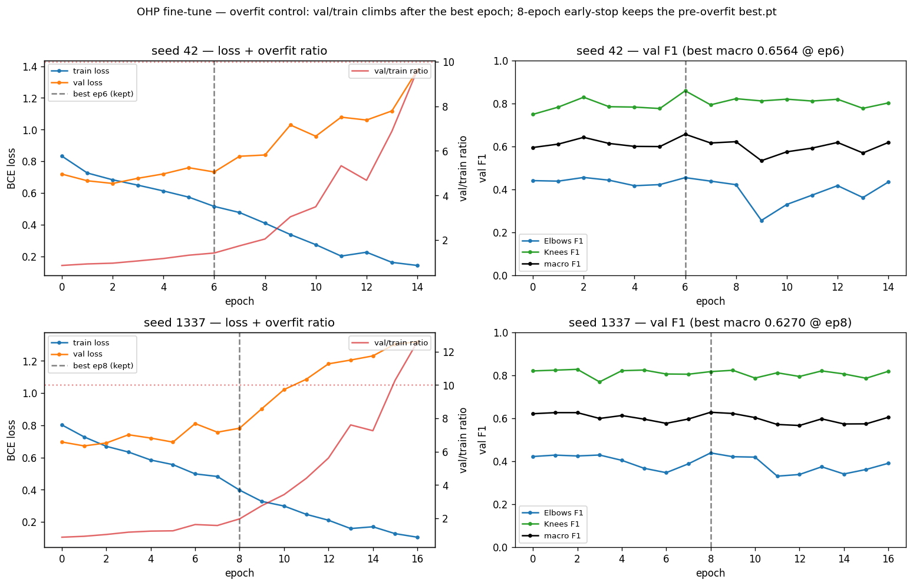
This figure shows why the early stop matters. Across the seeds the gap between training and validation widens past a certain epoch as the network begins to memorise, and the kept checkpoint is taken from before that point, so the deployed model is the one that still generalises rather than the one that has started to overfit.
The effect on the test scores is a clear, measured lift over the baseline. On the squat, the macro F1 rises from 0.543 to 0.6304, with the rare inward-knee error climbing from 0.286 to 0.4198 and the common forward-knee error from 0.800 to 0.8410, a gain of 0.087 that matches the published self-supervised result of 0.6262. On the overhead press, the macro F1 reaches 0.6622, with the elbow error at 0.4474 and the knee error at 0.8770, a gain of 0.050 over its own baseline that edges past the published 0.6502, mostly on the knee error. The decision thresholds, chosen on the validation split, come out at 0.614 and 0.385 for the two squat errors and 0.357 and 0.476 for the two overhead-press errors, which reflects how differently a rare and a common error sit. Test-time augmentation, which averages a model's output over small transforms of the input, was tried as a further step and then dropped, because it helped on the validation split and reversed on the test split, and a technique that does not hold on unseen data does not belong in the deployed model.

The image error: ResNet-18 with pose-contrastive pretraining
The fifth error, whether a squat reaches depth, is the one that can be judged from a single still frame rather than from motion, so it is handled by an image model instead of a video one. The model is a ResNet-18 [10], started from weights pretrained on ImageNet [33], and it is improved with the same idea as the video models, self-supervised pretraining, but in the form the dataset's authors designed for images, Cross-View Cross-Subject Pose Contrastive learning. The task builds triplets of frames in which an anchor pose is paired with the same pose seen from a different camera or performed by a different person as the positive, and a different pose as the negative, so the network learns a representation of body pose that does not depend on who is in the frame or where the camera is, which is exactly the kind of nuisance variation that wrecks a depth judgement in the wild [3], [25].
Two honest points belong with this model. First, the loss that was implemented is the one in the dataset's official code, a three-term distance-ratio loss, rather than the two-term loss written in the paper's equation; the two differ, and this report follows the code because the code is what the released results came from, but the deviation is stated rather than hidden. Second, the frames for pretraining were extracted from the unlabelled clips with care to avoid leakage: clips that overlap the labelled evaluation set were held out before extraction, leaving about 4,791 clips and some 581,503 frames to learn from, so no frame the model trains on can reappear at test time. Over a hundred epochs of this pretraining, a measure of how well the learned features separate the triplets rises from about 0.48, little better than chance, to 0.959.
Figure 13 - CVCSPC pretraining and fine-tuning for the depth error
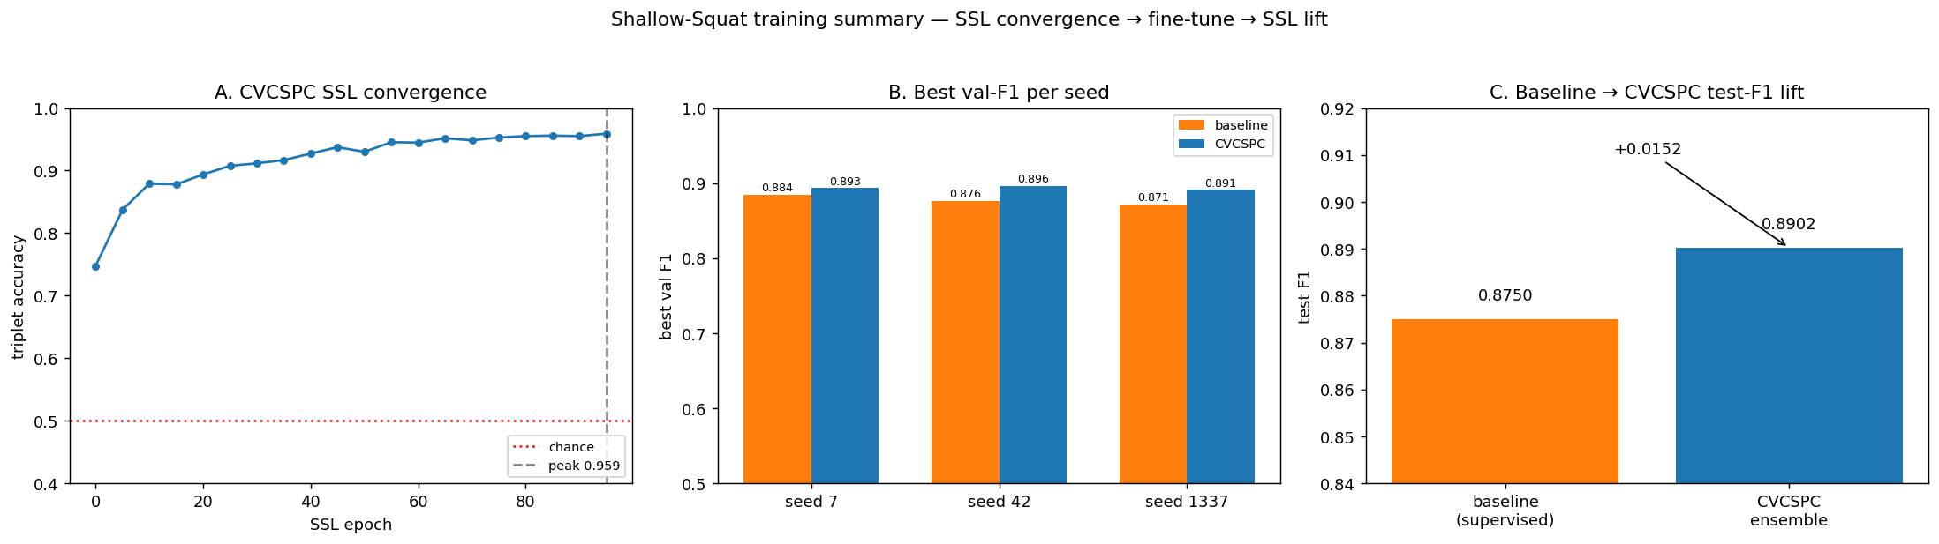
Figure 13 shows this. The triplet measure climbs steadily through pretraining toward 0.959, the per-seed validation scores of the fine-tuned classifiers settle close together, and the small but real gain of the pretrained model over the plain baseline is visible at the end.
Fine-tuned and ensembled across three seeds in the same way as the video models, the depth model reaches a test F1 of 0.8902, a gain of 0.0152 over its own supervised baseline of 0.8750 and above the published result of 0.8694, with its decision threshold set at 0.395 on the validation split.
One detail of this model needs to be stated plainly, because it is easy to get backwards. The dataset's label 1 marks the deeper squat, the one that does reach depth, which was confirmed by checking the pose geometry of the labelled frames. The model is therefore a depth detector, read as a high score meaning the squat reached depth. The result is steady whichever way the convention is read: scored as it is the F1 is 0.8902, scored the other way it is 0.9050, and the balanced average of the two is 0.8976, so the model's quality does not hang on the direction of the label. The below figure shows example frames on either side of the label so the convention is unambiguous.
Figure 14 - Shallow-squat depth, example frames by label
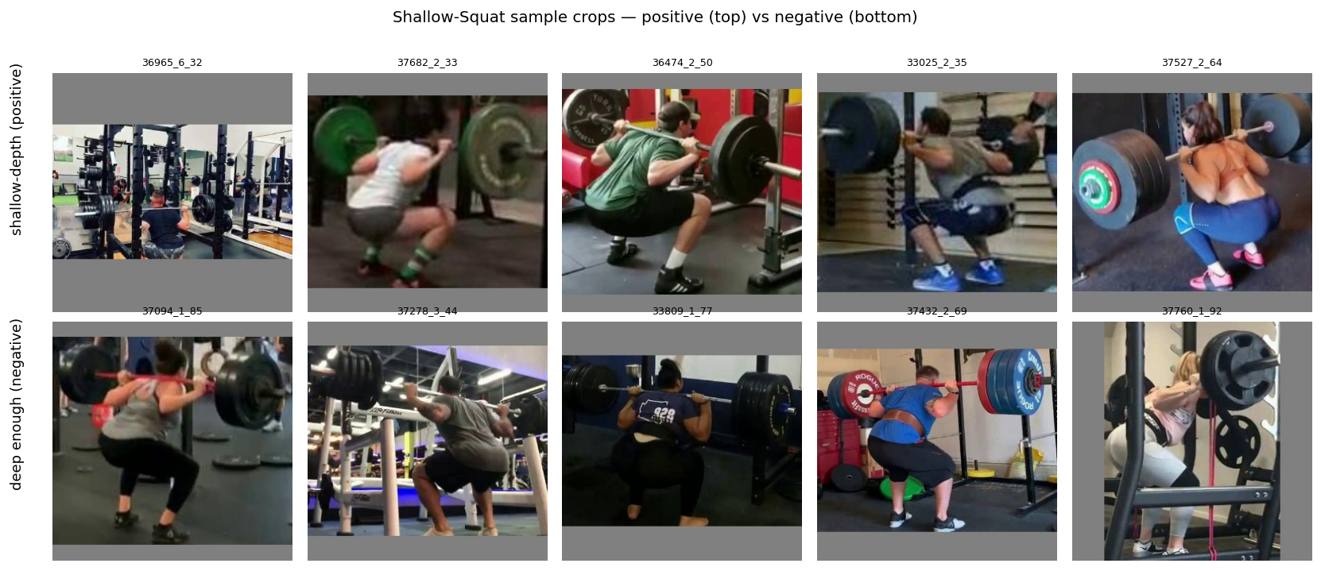
It places a few frames the dataset labels as reaching depth next to a few it labels as too shallow, which makes the convention concrete and shows the kind of in-the-wild frames the model has to judge.

Ensembles and serving
The three models, the squat video model, the overhead-press video model, and the squat depth image model, are deployed as a serving layer inside the same backend as the recommender. Each is loaded once at startup and answers requests as a small ensemble, three networks for the squat and the depth model and two for the overhead press, with their sigmoid outputs averaged and compared with the per-error thresholds. For a recorded clip the upload endpoint decodes the video, reduces it to the 32 frames the model expects with the same crop and normalisation used in training, and treats the whole clip as one repetition, which fits the way the dataset clips were collected. The depth model takes a single frame instead. The live camera path adds a small step that watches the motion energy of the incoming frames, with no pose estimate at all, and triggers the model when a repetition ends, and each live connection is given its own isolated state.
For the squat model, the most used path, each network is also exported to the ONNX runtime, which runs the same computation about 1.6 times faster on the processor with the outputs matching the original to within about 2.4 parts in ten million, so the speed-up costs nothing in accuracy. A benchmark inspector reuses these exact services and runs them over the dataset's own test clips, 244 for the squat, 339 for the overhead press, and 540 for the depth model, showing each model's output beside the expert ground truth so the result can be checked rather than trusted.
There is one hard limit to state plainly, and it is the same limit the dataset's authors built their work around. These models are reliable on footage like the data they were trained on, real gym video shot from the side with the whole body in frame, and they are close to random on a casual, front-facing phone clip taken at arm's length. This is why the user-facing part of the form feature was reframed as a benchmark inspector rather than a general camera tool: the honest thing to ship is a system that demonstrates the measured result on the data it was measured on, and says so, rather than one that pretends to work on any video.

Approaches explored and cancelled
The Fitness-AQA approach was not the first one tried for form correction. Several earlier designs came before it, and they are recorded here honestly, both because the report should be honest and because the reason they failed is what justifies the final choice. They all failed for one technical reason, which is worth stating once: each relied on labels that stood in for real form rather than being real form, and a model can only ever learn the labels it is trained on. Table 6 lists them, and the paragraphs that follow take each in turn.
Table 6 - Form-correction approaches that were investigated and rejected
Approach | Data and Labels | Why it was rejected
Pose plus multi-task temporal CNN | MediaPipe pose on Fit3D motion capture, synthetic corruption labels | Passed held-out motion-capture tests but performed very bad on real phone video, its quality output never correlated with real quality above about 0.3
Pose graph network (ST-GCN) | MediaPipe pose on Fit3D; synthetic angular-perturbation labels | Rated bad squats higher than good ones on real clips. the labels described the perturbation, not human form
Pose graph network on real video | ST-GCN on QEVD real clips; labels derived from coaching text by a keyword lexicon | Learned the per-exercise prior rather than the form, because the text labels tracked the exercise type
Vision-language model and distillation | A large multimodal model, with a distilled pose-plus-pixel student | Set aside on feasibility: the raw-video corpus was infeasible to move at the available upload speed, and the multimodal model needs several high-end accelerators and scores below the chosen method

The first serious attempt reduced each video to a stream of body joints with a pose estimator [12] and fed that stream to a multi-task temporal convolutional network that tried to predict, all at once, which exercise was being done, how well it was done, where each repetition began and ended, and which joints were at fault. It was trained on Fit3D, the studio motion-capture dataset of fitness movements introduced with the AIFit work [23], with the form errors created synthetically by perturbing a clean repetition and labelling the joint that was moved. On held-out motion-capture data it looked healthy, reaching an accuracy near 0.88 on a held-out subject and a joint-error F1 around 0.61. On real phone video it fell apart: it labelled squats as burpees, its quality score sat near 0.85 whatever the form, the joint-fault channels flatlined to zero, and it detected no repetitions at all. Its quality output, the part meant to judge form, never correlated with real quality above about 0.3 across repeated retraining, well under the 0.65 it needed. The synthetic corruption and the studio capture had taught it a world that real video does not belong to.
The second attempt kept the pose idea but replaced the temporal network with a spatial-temporal graph convolutional network, the standard architecture for skeleton data [34], and labelled the data by perturbing joint angles rather than positions. It was tested directly on the thing that matters, whether it rates a good squat above a bad one, on real squat clips. It did the opposite: the average score it gave good squats came out about 0.05 below the average it gave bad ones, where a useful model would need a clear positive gap. The cause was the same as before in a new form. The labels were the ground truth of the perturbation, a known amount of corruption added to a clean signal, and the network learned to detect that corruption, which is not the same thing as judging a real person's form.
The third attempt changed the data instead of the model, moving the same graph network onto QEVD, a large dataset of real exercise videos annotated with natural-language coaching feedback [24], on the reasoning that real video would fix the transfer problem. It did not, because the labels were still a proxy. QEVD does not carry a clean yes-or-no for each form error; its feedback is free coaching text, and to train a classifier that text had to be turned into labels by a keyword lexicon. Because the wording of coaching feedback follows the exercise more than the fine detail of the form, the derived labels were correlated with the exercise type, and the network took the easy path and learned the per-exercise prior rather than the form. On the same good-versus-bad test it scored a gap of about +0.004, essentially zero. A hand-written geometric rule was attached as a stopgap, which only confirmed that the learned model was not carrying the load, and a later multi-label variant on the same data was shelved for the same labelling reason.
The last attempt before the change of direction went toward a large multimodal model that reads video and language together, with a plan to distill its judgements into a smaller student combining pose and raw pixels. This one was set aside less on accuracy than on feasibility. The raw-video corpus needed to train the student ran to hundreds of gigabytes, which at the available upload speed would have taken on the order of two weeks just to move, and the small subset that could be moved would have been too little to train a video network from scratch without overfitting. The large multimodal model itself, the same LLaVA-Video line discussed in the related work [27], needs several top-end accelerators to run and, when others have measured it on this very dataset, scores below the specialised method. So the direction was closed.
The common thread is plain in hindsight and is the justification for the final design. Every rejected approach learned from a label that was a stand-in for form, a synthetic perturbation or a word in a coaching note, and so every one of them learned the stand-in instead of the form and failed when it met a real lifter. The Fitness-AQA approach is the answer to exactly this: real in-the-wild video, labelled error by error by expert trainers, and scored with the same metric the published work uses. The numbers earlier in this section are what building on that footing produced, and Chapters 5 and 6 test them.

Nutrition Pipeline
The nutrition pipeline is the platform's third module, and it takes the design principle of Section 3.1 to its strongest form: every number and every food is decided by fixed rules, and a language model is allowed only to describe the result. This section covers the recipe data it draws on, the deterministic engine that turns a profile into calorie and macronutrient targets, the selector and planner that build a meal plan from real recipes and guarantee it is correct, and the crew of language agents that explains it. A separate piece of nutrition work, a reproduction of a published recipe-text generator, is described in the section after this.

The Food.com recipe data
The recipes come from Food.com, the dataset used by Majumder et al. for their work on recipe generation [4]. The project uses the dataset's official splits, and they reconcile exactly to the figures in that paper: 698,901 training, 7,023 validation, and 12,455 test interactions, over 178,265 recipes and 25,076 users. For the meal-planning side of the module what matters is the recipes and their nutrition, so the recipes are cleaned into a runtime pool. Recipes whose stated energy falls outside a sensible range of 20 to 1,500 calories are dropped, as are recipes whose calorie figure does not agree with the sum of its macronutrients to within 30 percent, and exact duplicates. These three filters remove 7,942, then 3,320, then 5 recipes, leaving 166,998, about 93.7 percent of the aligned set. Each recipe's grams of protein, carbohydrate, and fat are recovered from the dataset's percentage daily values using the standard reference amounts, so the planner works with real macronutrient numbers rather than the dataset's coarse calorie band alone.
Figure 15 - Recipe cleaning waterfall
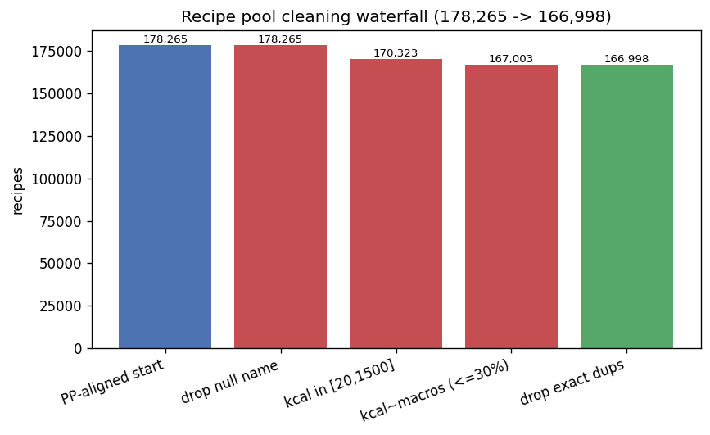
Figure 15 shows this cleaning as a waterfall, from the 178,265 recipes the dataset aligns to, down through the three filters, to the 166,998 that remain. The largest single cut is the energy range, which removes the recipes with implausible calorie figures that would otherwise let the planner build a day around a single mis-recorded dish.

Deterministic calorie and macro engine
The engine that sets a user's targets is a short chain of well-established formulas with no learning in it at all. It starts from the body-mass index, then computes a resting metabolic rate with the Mifflin-St Jeor equation [14], which adds 10 times the weight in kilograms and 6.25 times the height in centimetres, subtracts 5 times the age in years, and then adds 5 for men or subtracts 161 for women. That resting rate is multiplied by an activity factor, from 1.2 for a sedentary user up to 1.9 for an athlete, to give the total daily energy the user spends. The target is this total adjusted for the goal, lowered by 20 percent to lose weight, left as it is to maintain, or raised by 12 percent to gain, and then clamped to a safe floor of 1,500 calories for men and 1,200 for women, so a weight-loss target can never drop to something unhealthy. The target is split into macronutrients by rule as well: protein at between 1.8 and 2.2 grams per kilogram depending on the goal, fat at 0.9 grams per kilogram, and carbohydrate filling whatever calories are left, with the fat and then the protein trimmed back if there is no room left for carbohydrate. Because every step is a formula, the same user always gets the same numbers, and those numbers are correct by construction.

Recipe selection and meal planning
Turning the targets into a plan is the job of a selector and a planner, and this is where the no-fabrication guarantee is actually enforced. The selector scores every recipe in the pool against a slot's calorie target and macronutrient ratio. A recipe more than twice the allowed tolerance away from the calorie target is removed outright, and the rest are scored on how close they sit, blended 60 percent on the calorie fit and 40 percent on how well the recipe's own split of protein, carbohydrate, and fat matches the target ratio. The ratio is used rather than the raw protein amount on purpose, so the selector does not simply pile up the highest-protein dishes and ignore everything else. Any recipe that breaks the user's diet or contains an excluded ingredient is removed first, matched on whole words so that excluding nuts, for instance, does not accidentally also remove nutmeg by a loose substring.
The planner splits the day into meals, breakfast, lunch, and dinner, with an optional snack, and gives each slot a share of the day's calories and the same macronutrient ratio. For each slot it asks the selector for its best candidates and picks the best one that has not already been used that week, so the plan keeps variety across the days. When the plan is assembled, a verify step re-checks the whole thing: it recomputes the totals against the calorie band, the macronutrient targets, and the allergen list, and reports whether the plan is clean. This verify step is the authoritative gate. Because the planner only ever selects within the calorie window and the macro scoring, and excludes forbidden ingredients before it selects, a plan that reaches this gate passes it. Across contrasting user profiles the planned days land within about 10 percent of the calorie target on average, between 99.8 and 99.9 percent of the time.

Annotation Crew
Only once the deterministic plan exists does a language model see it, and even then only to describe it. A crew of four agents runs on a hosted GPT-4o-mini model: a Dietitian that explains the calorie and macronutrient targets in words, with an explicit instruction not to change any number; a Composer that gives the plan a title and a short theme for each day, drawn from the real recipe names and told not to invent recipes; a Critic that judges the plan's quality and variety; and a Coach that adds practical preparation and adherence tips. The Critic runs the verify step itself before it scores, and its score is hard-capped at a low value if the plan is not clean, so the language model can not call a broken plan good. What the crew returns is added alongside the plan, the day themes, the title, the rationale, the quality note, and the tips, while the actual days, meals, and totals come straight from the planner and are never touched. Hallucinated recipes and broken macronutrients are therefore impossible by design rather than something caught after the fact, and the whole feature still works with no language model at all, falling back to fixed template text that carries the same correct numbers. This crew runs inside the main backend process with direct calls to the language model rather than through CrewAI, unlike the workout-plan crew, so it does not need a second isolated environment for that framework's dependencies.

Recipe-text generator
The nutrition module includes one piece of work that is a research result in its own right rather than a part of the meal-planning system: a reproduction of the recipe-instruction generation task from Majumder et al. [4], the same paper the recipe data comes from. The task is to write the cooking steps for a recipe given its name, its ingredients, and a calorie level, and the paper introduced several models for it. The aim here was to see whether a modern pretrained language model, fine-tuned on the same task and measured the same way, could match or beat those models.
The paper's official code was taken and brought up to date to run on the current version of PyTorch, with its original licence and headers kept intact, and its published models are used as the points of comparison. The new model is DistilGPT-2, a smaller, distilled version of the GPT-2 language model [35], fine-tuned on the task: the input is the recipe's name, ingredients, and calorie level, the target is the cooking steps, and the loss is computed only on the step tokens, so the model is graded on what it generates rather than on the prompt it is handed. It is fine-tuned for 2 epochs at a low learning rate and decodes greedily, with a rule that forbids repeating any three-word sequence so it does not fall into loops. One honest note belongs here: a faithful re-run of the paper's own older model was attempted as well, but it hit a training bug that leaked the target into the input, so it was discarded, and the paper's published numbers are used as the anchors instead of a re-run.
The model is evaluated on the official test split with the same overlap and diversity measures the paper reports, BLEU and ROUGE for how closely the generated steps match the real ones, and Distinct for how varied the wording is. Table 7 puts the result next to the paper's models. On a sample of 2,000 of the test recipes, the fine-tuned DistilGPT-2 beats all three of the paper's learned models on every one of the five measures, and against the paper's non-learned nearest-neighbour baseline, which simply retrieves an existing recipe's steps, it wins on four of the five, the exception being one diversity measure where retrieving a real recipe is naturally varied.
Table 7 - Recipe-instruction generation, DistilGPT-2 against paper results
Metric | NN Retrieval | Encoder-Decoder | Prior-Name (paper’s best) | DistilGPT-2 (FitNova)
BLEU-1 | 20.28 | 28.39 | 28.05 | 29.15
BLEU-4 | 0.47 | 3.39 | 3.21 | 6.34
ROUGE-L | 16.87 | 25 | 24.79 | 26.45
Distinct-1 | 0.93 | 0.22 | 0.23 | 1.42
Distinct-2 | 9.39 | 1.93 | 2.08 | 7.66

Figure 16 - DistilGPT-2 fine-tuning loss
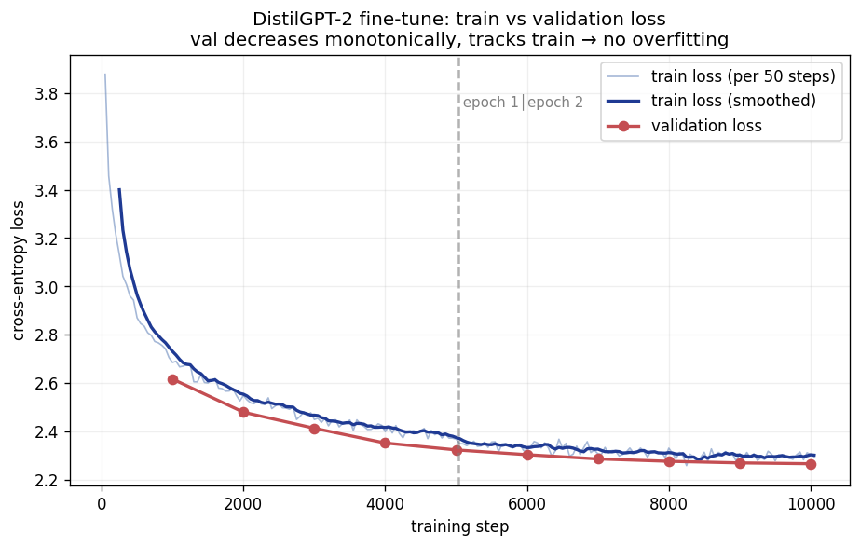
The above figure shows the fine-tuning and how the validation loss fall smoothly from about 2.62 to 2.27 and stays a little below the training loss throughout, and it is still falling when training stops at two epochs, so the model is not overfitting and could likely be pushed a little further. The head-to-head comparison figure against the paper's models is in Chapter 6, with the rest of the results.
Two limits have to be stated clearly so the claim is not read as more than it is. First, what this work matches and beats is the quality of the generated text; the paper's real contribution was something else, personalisation, generating steps conditioned on a user's cooking history and judged by whether the right user's recipe is recovered. This reproduction does not condition on a user and does not attempt that measurement, so the comparison is like-for-like on text quality and not on the thing the paper set out to do. Second, the numbers are from a 2,000-recipe sample of the roughly 11,700 test recipes, and a full-set run is the obvious next step that will replace them when it is done. Perplexity, a common language-model measure, is deliberately left out of the comparison, because the models use different tokenizers and their perplexities are not on the same scale, so comparing them would mislead. The record behind these numbers is a results file and a written summary kept in the repository rather than the exploratory notebook, which is kept only for provenance.
This completes the implementation and shows how the three pipelines have been built on their datasets, trained, assembled, and then wired into one backend. And how the form detection and correction earlier designs were viewed and walks through the process.

Testing and evaluation
This chapter covers how the system was tested and how it was evaluated. Testing, in 5.1, is about whether the parts behave as they should and, more than that, whether the system can be trusted not to make things up. Evaluation, in 5.2, is about the protocols and the metrics behind every number this report quotes, so the results in the next chapter can be read with confidence. The two are kept apart because they answer different questions: testing asks whether the code is correct and honest, and evaluation asks how good the models are and against what.

Testing
Testing here means three things. There are the ordinary automated tests that check the parts of the system work. There are a small number of special checks whose only job is to stop the system from fabricating a number or a piece of feedback. And there is a separate audit that asks whether the trained models are genuinely good or have simply memorised their training data. Each is described in turn.
The backend carries a broad automated test suite written with pytest. It covers the recommender from end to end, from the content filter's scoring against the program catalogue, through the plan adapter, to the chat intake, with the language model calls mocked so the tests are fast and deterministic. It covers the three form services, checking that each one builds, degrades gracefully when its weights are missing, applies the right per-error thresholds, and returns the raw schema with no invented fields, and it covers the serving endpoints, the benchmark catalogue's clip counts, and the path-traversal guard on the media endpoint. It also covers the offline metric and ensemble code that produced the headline numbers, the angular-feature geometry, and the configuration files that map exercises and defects. The Flutter app has its own smaller suite, 38 tests across 9 files, covering the data models, the benchmark filtering logic, and the result screens, including the states where there is no ground truth or no detected repetition. The nutrition engine is the one part without a dedicated unit-test file; it is checked at run time by its own verify step instead, described shortly.
Beyond the ordinary tests, a few checks exist for one reason only, to make fabrication impossible to ship unnoticed. The first lives in the evaluation notebook. Rather than have the headline F1 scores typed into the report by hand, the notebook recomputes all five of them from the raw per-clip score arrays at the stored validation-tuned threshold, and asserts that each one matches the saved result to within a millionth, so a headline number can not drift away from the data it claims to come from. The second checks the deployed models against those same saved results: a cross-check test runs the live serving path on sample clips and fails if the score it returns differs from the stored one by more than 0.02 for a video or 0.001 for an image, which proves that the model a user actually hits gives the same answer as the model that was evaluated. The third guards the feedback itself: a test scans the whole app for a list of banned severity and coaching words, the kind of confident language the system is forbidden from inventing, and fails if any of them appear in the code. The fourth guards the ground truth: the field that holds a clip's true label is read as a value that is absent when the dataset does not provide it, and is never quietly turned into a zero, with a test that asserts exactly this, so the app can never show an invented ground truth beside a model's guess.
Two deterministic verifiers sit inside the running system as well, and they are part of why the no-fabrication guarantee holds rather than being a hope. On the planning side, the plan validator counts a hard violation whenever a plan has the wrong number of training days, puts an exercise on the wrong kind of day, asks for equipment the user lacks, or includes a movement that clashes with an injury, and its repair step fixes these using only exercises from the dataset pool, never inventing one. On the nutrition side, the meal verifier re-checks every meal against the user's allergens and diet as a strict pass-or-fail gate, and the planner's critic refuses to award a good score to a plan that fails it. The calorie and macronutrient numbers do not need a gate of their own, because they are computed by formula and the planner only ever selects inside them, but the verifier reports how closely the finished plan matches them so the match can be seen rather than assumed.
The last and most involved piece of testing is the overfitting audit, which exists because a model that scores well can still be a model that has memorised a few hundred training examples, and on a dataset this small that risk is real. The audit examines every trained form model, baseline and self-supervised, every seed and every error, along seven lines of evidence. It confirms that the stored headline scores reproduce from the raw per-clip scores; it reloads each model from its actual saved weights and re-runs the official evaluation to confirm the saved scores were not edited; it checks that each saved model was taken from before its validation loss began to rise; it measures the gap between validation and test performance, at both the tuned-threshold F1 and the threshold-free precision-recall area, with confidence intervals; it checks that a model fails the same way on validation and on test; it checks that the results are stable across seeds and that the self-supervised features did not collapse; and it measures the gap between training and test performance, which is where memorisation shows up.
Figure 17 - Saved Weights Evaluation
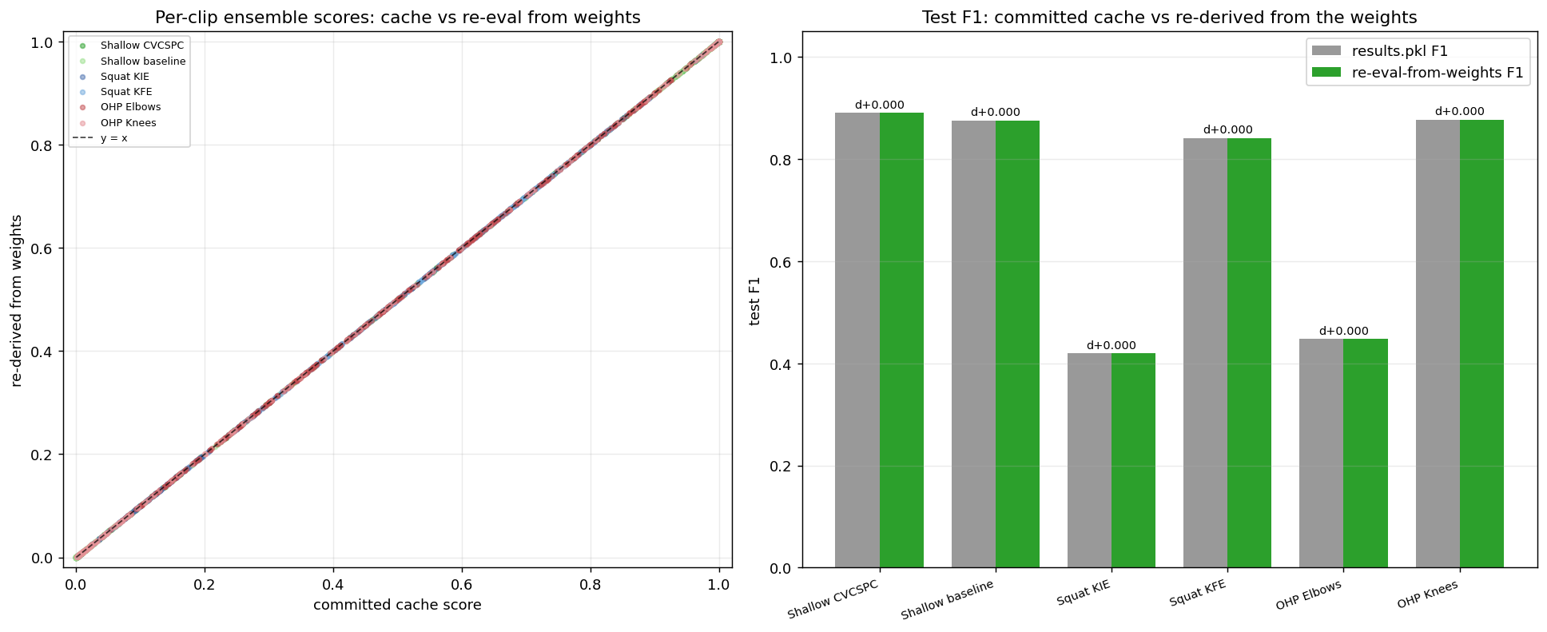
This figure shows that every score came back matching the stored result with a difference of zero, which means the numbers in this report are the numbers the saved models actually produce. The audit's overall verdict is that no deployed model shows validation-to-test overfitting: validation tracks test within sampling noise on every measure. The verdict is careful not to claim zero overfitting in the strict sense, because the two rarest errors, the inward-knee squat error and the elbow overhead-press error, do show a large gap between training and test performance, the mark of a model leaning on memorisation where there are only a few hundred positive examples to learn from. That gap is bounded, because validation still tracks test and the test scores still match the published work, and the self-supervised pretraining shrinks it.

Evaluation
The evaluation of every module follows one rule, already stated but worth repeating because it is the thing that makes the results comparable: each module is measured with the same metric, on the same official split, as the published work it is set against. This section explains those metrics and protocols, one module at a time, so the numbers in Chapter 6 can be read without ambiguity.
The form models are measured by the F1 score for each error, which is the metric the Fitness-AQA work reports. F1 is the harmonic mean of precision, the share of the model's positive calls that are correct, and recall, the share of the real errors the model catches, and it is the right choice here precisely because the errors are imbalanced: a model could reach a high plain accuracy on the rare inward-knee error by simply never calling it, and F1 refuses to reward that, because such a model would have zero recall. Each model is run on the dataset's official test split exactly as released, and the decision threshold that turns a probability into a yes or no is set beforehand on the validation split, never on the test split, so the reported F1 is not quietly tuned to the data it is reported on. The per-error scores are summarised per exercise as a macro average, which weights the rare and the common error equally rather than letting the common one dominate.
Figure 18 - Precision-recall for squat errors
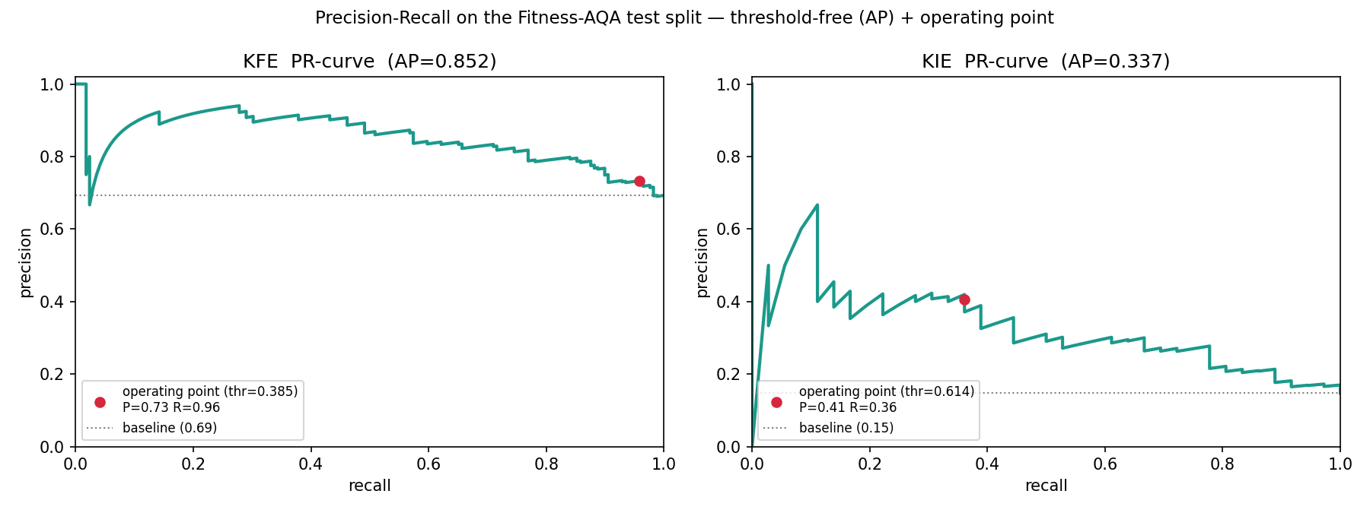
The figure above shows precision-recall for the squat. Each curve traces how precision trades against recall as the threshold moves, the marked point is the operating threshold chosen on the validation split, and the area under each curve, a single threshold-free score, is what the overfitting audit compares between validation and test so that the comparison does not depend on the chosen threshold. The same audit also reads the area under the receiver-operating curve, another threshold-free measure, for the same reason.
The recommender is measured the way He et al. measure neural collaborative filtering, by a leave-one-out protocol. For each of the 973 users one positive interaction is held out, and the model is asked to rank that held-out program against 99 programs the user did not interact with. Two numbers come from this. The hit rate at 10 is the fraction of users for whom the held-out program lands in the top 10 of the 100, a simple did-it-find-it measure. The normalised discounted cumulative gain at 10, a measure from the information-retrieval literature [36], is more demanding: it rewards the held-out program for ranking near the very top and discounts it as it falls down the list, so a model that puts the right answer first scores higher than one that merely sneaks it into tenth place. As Section 4.1 set out, both numbers are computed on the synthetic interaction data, so they show how faithfully the model reconstructs the synthetic pattern and are not a claim about real-world recommendation quality.
The nutrition module is evaluated in two parts, for its two very different jobs. The recipe-text generator is measured with the same three families of metric the recipe-generation paper reports. BLEU [37] measures how much of the generated text's short word sequences appear in the real instructions, reported at one-word and four-word lengths, so a higher score means the wording is closer to a real recipe. ROUGE [38] measures the overlap the other way round, how much of the real instructions the generated text recovers, along the longest shared sequence of words. Distinct [39] measures something different again, the fraction of the generated word sequences that are unique, which is a measure of variety rather than of accuracy and guards against a model that says the same safe thing every time. All three are computed on the dataset's official test split. Two honest points carry over from Chapter 4: the figures are from a 2,000-recipe sample of the test set with a full run still to come, and perplexity, a fourth common measure, is left out because the models being compared use different tokenizers and their perplexities are not on the same scale.
Figure 19 - Generalisation of the recipe generator
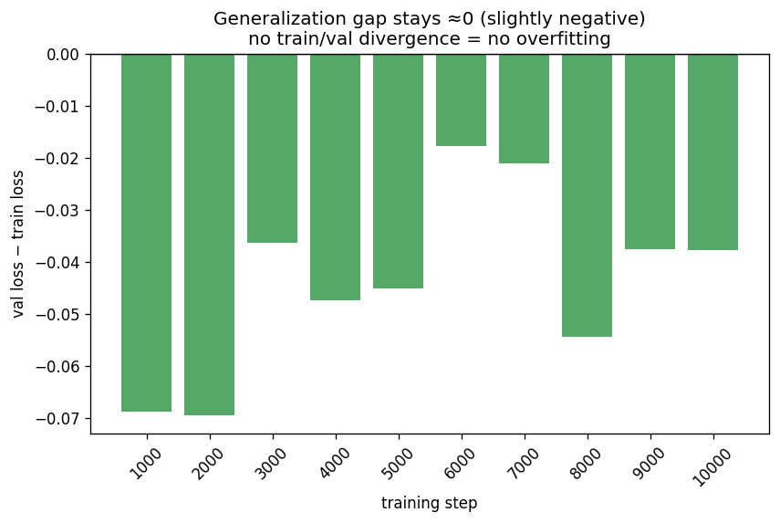
This figure shows the gap between the generator's training and validation loss at each checkpoint, and the gap stays slightly negative throughout, which means the model does no better on the data it trained on than on data it has not seen, the clearest sign that the result is not an artefact of overfitting.
The deterministic meal planner is not evaluated by a learned metric, because there is nothing learned in it to measure; it is evaluated by whether it keeps its guarantee. The relevant numbers are the share of planned days that land inside the calorie band and the closeness of the planned macronutrients to their targets, both reported in Chapter 6, together with the fact that no plan in testing contained an excluded ingredient. For a deterministic system, a guarantee that holds across many profiles is the evaluation.

Results and Discussions
This chapter brings the numbers together and discusses what they mean. It takes each module in turn, the form models against the published method, the recommender, and the nutrition work, and then steps back to discuss the limits of the results, where they are strong and where they stop. The numbers here are the ones defined and tested in Chapter 5, drawn from the committed result files.

Form Correction Results
The form models were built to be compared, error for error, with the published Fitness-AQA method on the same official test split, and Table 8 makes that comparison. For each of the five errors it shows the project's plain supervised baseline, the deployed self-supervised model, and the two numbers the paper reports, its own self-supervised model and, where it gives one, its supervised baseline.
Error | FitNova Baseline | FitNova Deployed (SSL) | Parmar SSL (Fitness-AQA Paper) | Parmar Baseline
Squat Knees-Inward (KIE) | 0.2857 | 0.4198 | 0.4186 | 0.2970
Squat Knees-Forward (KFE) | 0.800 | 0.8410 | 0.8338 | 0.8184
OHP Elbows | 0.4167 | 0.4474 | 0.4552 | —
OHP Knees | 0.8069 | 0.8770 | 0.8452 | —
Shallow-squat Depth | 0.8750 | 0.8902 | 0.8694 | —

The headline is that the deployed models match or beat the published self-supervised result on four of the five errors and trail it only narrowly on the fifth. On the squat they reach 0.4198 on the rare inward-knee error and 0.8410 on the forward-knee error, both a touch above the paper's 0.4186 and 0.8338. On the overhead press they reach 0.8770 on the knee error, clearly above the paper's 0.8452, and 0.4474 on the elbow error, a little below the paper's 0.4552. On the squat depth image the model reaches 0.8902 against the paper's 0.8694. Figure 20 draws these side by side, and it shows two things at a glance: how close the project's bars sit to the paper's, and, on the squat, how far both self-supervised results stand above the plain supervised baseline.
Figure 20 - All five errors, FitNova against Parmar et al.
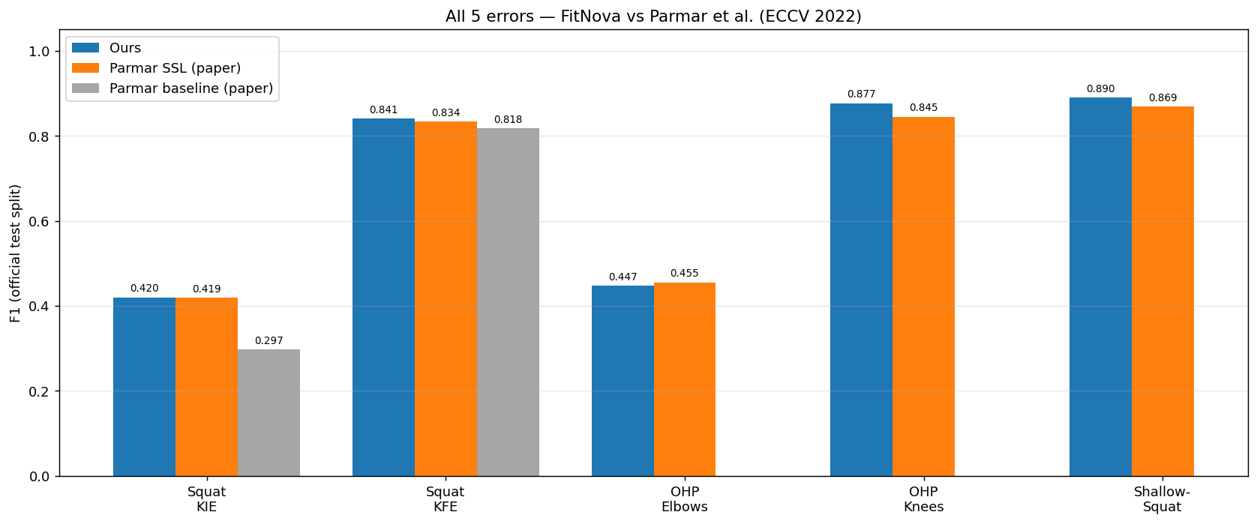
Read per exercise rather than per error, the result is a clean win on all three. Figure 21 shows the macro F1, the average of an exercise's errors that weights the rare and the common one equally: 0.6304 against the paper's 0.6262 on the squat, 0.6622 against 0.6502 on the overhead press, and 0.8902 against 0.8694 on the depth image. The depth result also sits above the other self-supervised methods the paper benchmarks for that error, which score around 0.83, so on that error the project's model is the strongest of the set.
Figure 21 - Per-exercise macro F1
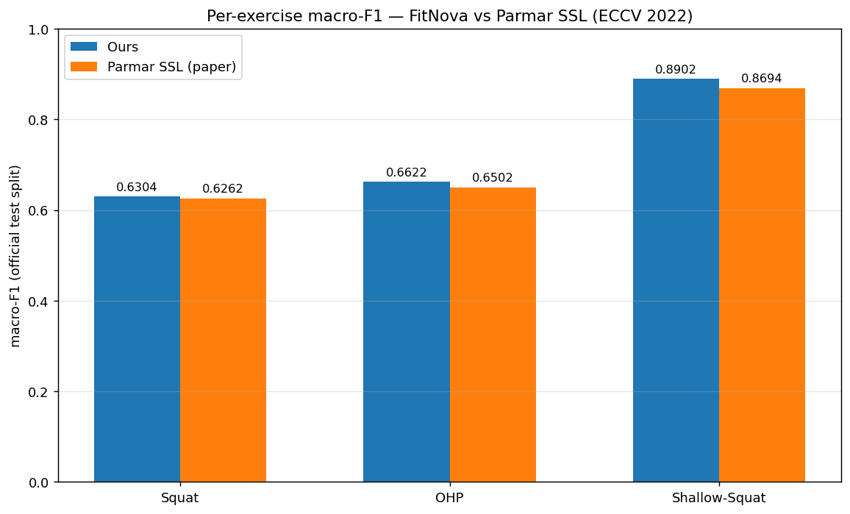
Numbers this close to a published result invite the obvious worry, that they come from a model that has memorised its small training set rather than learned the errors, and Chapter 5 described the audit built to test exactly that. Its conclusion, drawn in Figures 22 and 23, is that the deployed models are not overfitting in the way that matters for deployment. Figure 22 puts the training, validation, and test score side by side for each deployed error, and the point to read off it is that validation tracks test for every one of them, the two never more than a few points apart. A model whose validation score predicts its test score is a model that will behave on new data as it did in development, which is what deployment needs.
Figure 22 - Deployed models: train, validation, and test F1 per error
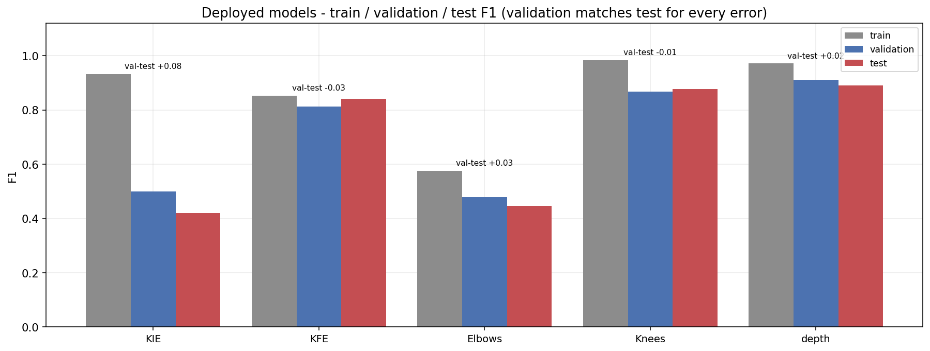
The same figure shows the honest other half of the picture. For the two rarest errors, the inward-knee squat and the press elbow, the training score sits far above the test score, about 0.93 against 0.42 for the inward-knee error. That gap is the mark of a model leaning on memorisation, which is hard to avoid when an error appears in only a hundred-odd training clips, and it caps how high those two errors can score. It does not break the result, because validation still tracks test and the test score still matches the published work, but it is a real limit and it is named as one.
The below figure shows how the self-supervised pretraining bears on this. For the overhead-press elbow error, the pretraining cuts the gap between training and test from about 0.53 down to 0.13, and the gap between validation and test from about 0.10 to 0.03, turning a badly overfitting supervised baseline into a deployed model that generalises. For the inward-knee squat error the same pretraining does something more honest to report: it lifts the test score from 0.29 to 0.42, a real gain, but it does so by fitting the training set harder, so the gap between training and test actually grows rather than shrinks. The lift is genuine and the test score matches the paper, yet the model reaches it partly by memorising more, and the figure shows that plainly rather than hiding it.
Figure 23 - The effect of self-supervised pretraining on the overfitting gaps
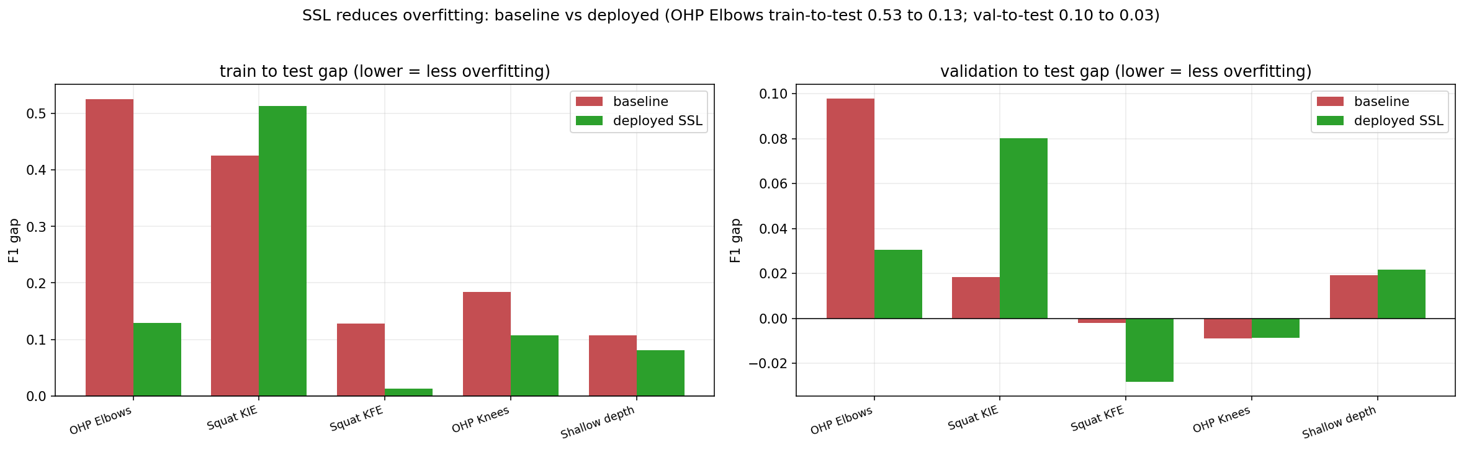
One last point sits in the same data and counts in the project's favour. The one model that does overfit in the deployment sense, with its validation score standing noticeably above its test score, is the overhead-press supervised baseline, the model that was measured but not deployed. That the discarded control overfits while the deployed models do not is itself evidence that the clean results are real rather than a lucky split.

Recommender results
The recommender was evaluated by the leave-one-out protocol of Section 5.2, over the 973 users, and the headline numbers are a hit rate at 10 of 0.9270 and a normalised discounted cumulative gain at 10 of 0.7469. Figure 24 places these next to the two halves of the model trained on their own, the generalised matrix factorisation part and the multi-layer perceptron part. The fused model is ahead of both on both measures: the matrix factorisation part reaches 0.9075 and 0.7251, the perceptron part 0.9065 and 0.7208, and joining them lifts the result to 0.9270 and 0.7469. The gain from the fusion is small on the hit rate and clearer on the ranking measure, which is the harder of the two, and this is the pattern the original method reports, that the two views of the interaction add something to each other [2].
Figure 24 - Recommender ranking quality
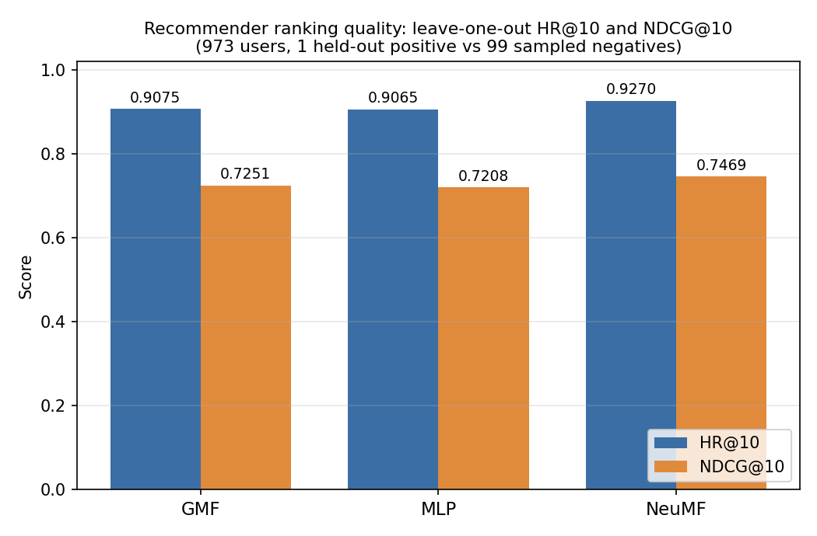
The caveat from Section 4.1 has to be carried into how this number is read. The model was trained and tested on synthetic interactions generated from a rule, so a hit rate of 0.9270 says that the neural model reconstructs that synthetic pattern very well. It is a faithful reproduction of the method on the data it was given, and it is not a measurement of how well FitNova would recommend to real users, which would need real interaction data to claim. The honest reading is that the modelling is sound and the evaluation is clean, while the data underneath is the part a deployed version would have to replace.

Nutrition results
The nutrition module produces two kinds of result, the quality of its recipe text and the correctness of its meal plans, and they are reported in turn.
For the recipe-text generator, Figure 25 draws the comparison from Table 7 against the paper's two learned models. On the overlap measures, the BLEU scores and ROUGE, and on the diversity measures, the two Distinct scores, the fine-tuned DistilGPT-2 sits above both of the paper's learned models on every bar. The clearest gaps are on the harder measures: the four-word BLEU score, where a small absolute number still represents close to double the paper's, and the two diversity scores, where the generated text is markedly more varied than the paper's models, which tend to repeat safe phrasings. The one place the model does not lead, as Table 7 records, is against the paper's non-learned nearest-neighbour baseline on the second diversity score, which is unsurprising, because that baseline simply returns a real recipe's text and real text is naturally varied. The framing from Chapter 4 holds here: this is a win on the quality of the generated text, measured the same way the paper measures it, and not a reproduction of the paper's personalisation, which conditioned on a user's history and which this work does not attempt.
Figure 25 - Recipe generation, DistilGPT-2 against the learned models of Majumder et al.
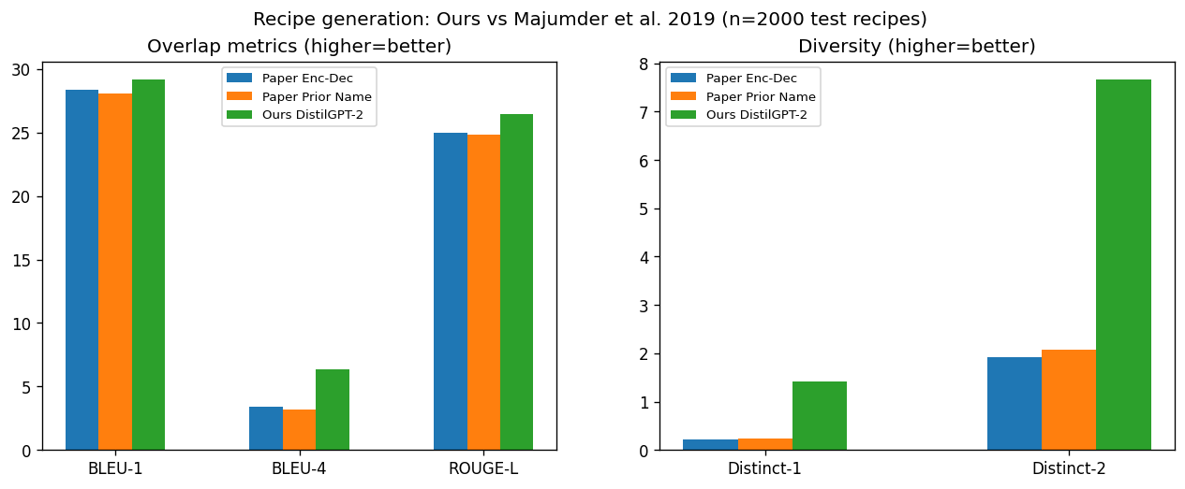

For the meal planner, the result is not a learned score but a guarantee, and the evidence for it is in Figures 26 and 27. Figure 26 plans a week for two contrasting profiles, a powerbuilding male on a gaining target of about 3,133 calories and a cutting female on a losing target of about 1,507, and shows the planned calories for each of the seven days against the target and a ten-percent band. Every day, for both profiles, lands on the target line, the average match being 99.8 percent for the first profile and 99.9 percent for the second. Figure 27 takes one of those days and shows the macronutrients the plan achieved against the targets it was given, 159 grams of protein against a target of 160, 448 grams of carbohydrate against 461, and 74 grams of fat against 72. These numbers are not learned and they do not vary from one run to the next; they are what the deterministic engine and selector produce by construction, and the figures are simply the proof that the construction holds across different bodies and goals.
Figure 26 - The meal planner hits the calorie target every day
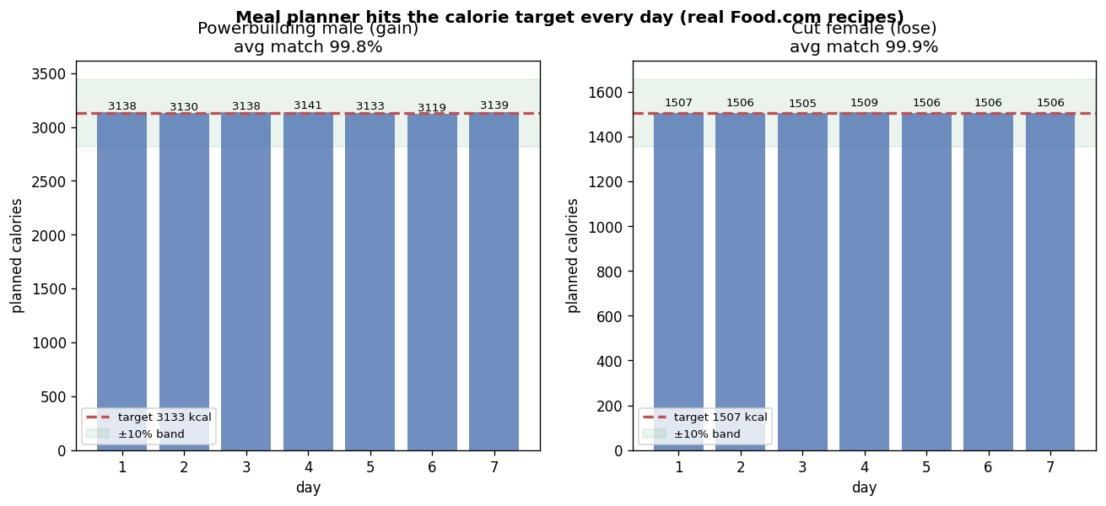
Figure 27 - Macronutrient targeting for a powerbuilding day, target against achieved.
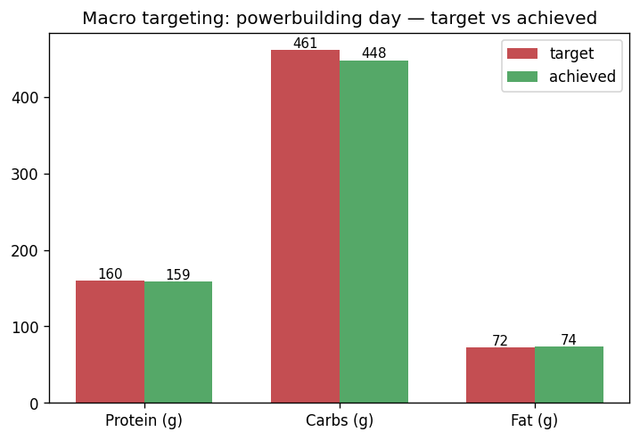
Together the two halves of the nutrition module show the split the design was built around: a learned part that competes on the quality of its language, and a deterministic part whose numbers are correct by construction rather than by a model getting them right.

Discussion
The results across the three modules share a shape. Each one was built on a published dataset and method and measured the same way, and each one matched or beat the work it was set against: the form models on per-error F1 against Parmar et al. [3], the recipe generator on text-quality metrics against Majumder et al. [4], and the recommender as a faithful reproduction of neural collaborative filtering [2]. That is the strong part, and it is the part that makes the work defensible, because a number measured the same way as published work and reproducible from a committed file is a number an examiner can check. But every one of these results has a limit, and the limits are worth stating together in one place, because reading them honestly is the difference between a result and an overclaim.
The first limit is the two hardest errors. The inward-knee squat error and the elbow press error are rare, present in roughly one clip in seven and one in four, and the results showed both deployed models leaning partly on memorisation of their few hundred positive examples, with the training score far above the test score. This is a ceiling set by the data, not a flaw in the method. There are only so many examples of a rare error to learn from, and a small model trained on a small positive set will fit them closely; the audit's value is that it makes this visible rather than letting the high training score pass as success. The limit is bounded, because the validation score still predicts the test score and the test score still matches the published work, so the rare errors are as good as the published method manages and no worse. But they are the errors a user should trust least, and the honest position is that these two detectors sit at the edge of what the data supports.
The second limit is the largest, and it is the gap between the benchmark and the real world. Every form number in this report is measured on the Fitness-AQA test set, which is real gym footage but of a particular kind, shot from the side with the whole body in frame, the way the dataset was collected. On a casual clip filmed front-on at arm's length with a phone, the same models are close to random, because that input is outside the distribution they learned. A fix would not remove this, because it is the boundary of what a model trained on one kind of video can do, and it is the reason the user-facing form feature was reframed from a general camera tool into a benchmark inspector that runs on the dataset's own clips and says plainly where it is reliable. It would be easy to demonstrate the model on a phone and let the gap go unmentioned; the project chose instead to ship the honest version and to state the limit, here and in the interface. Closing this gap would need training data from the casual-phone domain, which the dataset does not provide, and that is left to the future work.
The third limit belongs to the recommender. Its hit rate of 0.9270 is a real number, computed cleanly by a standard protocol, but it is computed on interaction data that the project generated from a rule, because no real record of user choices exists. The number therefore measures how well the neural model reconstructs that synthetic pattern, and it is strong evidence that the modelling is implemented correctly, but it is not evidence about how the recommender would perform for real people, whose behaviour a rule only approximates. The content-based and goal-based parts of the pipeline work from the real user profile and do not depend on this data, so a user still gets a sensible, goal-matched plan, but the learned re-ranking layer is the part whose real-world value can not be claimed until real interaction data exists to retrain and re-measure it.
The fourth limit is narrower and was stated when the result was. The recipe generator beats the published models on the quality of its text, but the published work's actual contribution was personalisation, writing a recipe shaped by a particular user's history, and this reproduction does not do that. The comparison is fair on the ground it claims, text quality measured identically, and the project is careful not to let a win on quality be read as a win on the thing the paper set out to do. The deterministic side of the nutrition module carries no such caveat, because its guarantee is structural and holds for any profile, but the generative side competes only on language.
None of these limits undoes the central result, which is that each module does what published work does, measured the same way, and the form module does it while an independent audit confirms the deployed models generalise. What the limits mark out is the distance between a defensible benchmark result and a finished product. The form models are ready as a benchmark and not as a phone app; the recommender is a correct model waiting for real data; the nutrition module is a correct planner with a competitive but non-personalised text layer. Naming that distance plainly is itself part of the contribution, because the failure that this whole project was rebuilt to escape came from the opposite habit, of building on numbers that looked good and did not hold. The work that would carry each module past its current limit is the subject of the next chapter.

Conclusions and Future Work
This chapter draws the project to a close. It summarises what was achieved against the objectives set out at the start, and then sets out the work that would carry each part of the system past the limits the results made plain.

Summary
FitNova set out to build three AI fitness modules in one platform, each grounded in a published dataset and method, and to report the results honestly. Measured against the objectives in Section 1.3, the project did what it set out to do.Future Work
Explain any limitations in your results and how things might be improved. Discuss how your work might be developed further. Reflect on your results in isolation and in relation to what others have achieved in the same field. This self-analysis is particularly important. You should give a critical evaluation of what went well, and what might be improved.
The platform itself was built (O1 and O6): three modules, planning, form correction, and nutrition, run inside one backend, each reading the user's profile and each independent enough that one can fail without taking the others down. The workout planner was built as the layered recommender of O2 and O3, a content-based filter, a Neural Collaborative Filtering re-ranker, and a language-model crew that writes a goal-matched seven-day plan from real dataset exercises only, with a deterministic validator that makes an invented exercise impossible. It reaches a hit rate at 10 of 0.9270 on its evaluation.
The form correction module is the deepest result and the one O4 was rewritten around. Rebuilt from raw pixels on the Fitness-AQA dataset after the earlier pose-based designs were dropped, it detects five named errors across three exercises and, on the dataset's official test split with the same per-error F1 the published work uses, it matches or beats that work, with a higher macro F1 on all three exercises and an independent overfitting audit confirming the deployed models generalise. That is a defensible, reproducible result of exactly the kind the project was rebuilt to produce.
The nutrition module met O5 in two parts: a deterministic engine and planner that guarantee the calorie, macronutrient, and allergen correctness of every plan before any language model speaks, and a DistilGPT-2 reproduction that beats the learned models of the recipe-generation paper on the text-quality metrics.
The last objective, O7, was about how all of this is reported, and it runs through the whole document: every headline number is computed on an official split with the source work's metric and is reproducible from a committed file, the approaches that failed are documented as honestly as the ones that worked, and the limits of each result are stated plainly. The project's central claim is modest and precise: each of its parts does what published work does, measured the same way, and this is shown rather than asserted. It does not claim to be a finished product.

Future Work
For form correction, the largest opportunity is the domain gap. The models are reliable on side-on, full-body gym footage and weak on casual front-facing phone video, and closing that would mean collecting and labelling video from the phone domain, then training on it, which the Fitness-AQA dataset does not provide. With reliable phone-domain models, the deferred live camera path, the real-time feedback over a websocket that the current system supports in the backend but does not expose to users, could be finished and shipped as a genuine camera tool rather than a benchmark inspector. The exercise coverage could also grow: the barbell row was scoped out of this milestone for time and compute and is the obvious next exercise, and the dataset carries more errors than the five used here. A graded sense of how wrong a repetition is, rather than a yes or no, would also be valuable, but only if a dataset with graded labels is used, because the current labels are binary and inventing a severity would break the honesty the project is built on.
For the recommender, the single most valuable step is real data. The model is implemented correctly, but it is trained and measured on synthetic interactions, so deploying the planner, collecting real user choices over time, and retraining on them would turn a clean reproduction of the method into an actual measurement of recommendation quality. Once a real history of user behaviour exists, a sequential model that reads the order of a user's choices rather than a static profile becomes possible [18], which is a natural extension that the current data can not support.
For nutrition, the obvious extension is the part of the recipe-generation paper this work deliberately did not reproduce, personalisation. Conditioning the generated cooking text on a user's own history, and measuring it the way the paper does, would close the one gap named in the results. On the deterministic side, the engine and planner already guarantee correctness, so the work there is less about accuracy and more about reach: more recipes, more cuisines, and an on-device version that would let the nutrition feature run without a server. The recipe-text metrics should also be finalised on the full test set, replacing the 2,000-recipe sample the current numbers come from.
Across all three, the step that would test the whole platform as a product rather than as three benchmarks is a study with real users, which would measure whether the plans, the feedback, and the meals actually help someone train better, rather than measuring an F1 or a hit rate. That is the boundary between what this project proved and what a deployed FitNova would need to prove, and it is the right place for the work to go next.
FitNova began as an attempt to build AI fitness features and, in its form-correction work, became a lesson in building them honestly. The version delivered here is grounded in published data and methods, measured against published results, audited for the failure it was most at risk of, and clear about where it stops being reliable. Those properties, more than any single score, are what the project set out to earn.
References
- A. A. Gedi, A. A. Khalif, M. A. S. Doon, A. A. Mohamed, I. A. Ali, and B. A. Ahmed, "Personalized Gym Recommendation System Using Machine Learning," Int. J. Eng. Trends Technol. (IJETT), vol. 73, no. 4, pp. 249-257, 2025, doi: 10.14445/22315381/IJETT-V73I4P122.
- X. He, L. Liao, H. Zhang, L. Nie, X. Hu, and T.-S. Chua, "Neural Collaborative Filtering," in Proc. 26th Int. Conf. World Wide Web (WWW), Perth, WA, Australia, 2017, pp. 173-182, doi: 10.1145/3038912.3052569.
- P. Parmar, A. Gharat, and H. Rhodin, "Domain Knowledge-Informed Self-Supervised Representations for Workout Form Assessment," in Proc. Eur. Conf. Comput. Vis. (ECCV), 2022, pp. 105-123, doi: 10.1007/978-3-031-19839-7_7.
- B. P. Majumder, S. Li, J. Ni, and J. McAuley, "Generating Personalized Recipes from Historical User Preferences," in Proc. Conf. Empirical Methods Natural Lang. Process. 9th Int. Joint Conf. Natural Lang. Process. (EMNLP-IJCNLP), Hong Kong, China, 2019, pp. 5976-5982, doi: 10.18653/v1/D19-1613.
- G. G. Panayotova, "Artificial Intelligence in Nutrition and Dietetics: A Comprehensive Review of Current Research," Healthcare, vol. 13, no. 20, Art. no. 2579, 2025, doi: 10.3390/healthcare13202579.
- C. Larman and V. R. Basili, "Iterative and Incremental Development: A Brief History," Computer, vol. 36, no. 6, pp. 47-56, 2003, doi: 10.1109/MC.2003.1204375.
- P. Lops, M. de Gemmis, and G. Semeraro, "Content-based Recommender Systems: State of the Art and Trends," in Recommender Systems Handbook, F. Ricci, L. Rokach, B. Shapira, and P. B. Kantor, Eds. New York, NY, USA: Springer, 2011, pp. 73-105, doi: 10.1007/978-0-387-85820-3_3.
- Y. Koren, R. Bell, and C. Volinsky, "Matrix Factorization Techniques for Recommender Systems," Computer, vol. 42, no. 8, pp. 30-37, 2009, doi: 10.1109/MC.2009.263.
- A. Krizhevsky, I. Sutskever, and G. E. Hinton, "ImageNet Classification with Deep Convolutional Neural Networks," in Proc. Adv. Neural Inf. Process. Syst. (NeurIPS), Lake Tahoe, NV, USA, 2012, pp. 1097-1105.
- K. He, X. Zhang, S. Ren, and J. Sun, "Deep Residual Learning for Image Recognition," in Proc. IEEE Conf. Comput. Vis. Pattern Recognit. (CVPR), Las Vegas, NV, USA, 2016, pp. 770-778, doi: 10.1109/CVPR.2016.90.
- D. Tran, H. Wang, L. Torresani, J. Ray, Y. LeCun, and M. Paluri, "A Closer Look at Spatiotemporal Convolutions for Action Recognition," in Proc. IEEE/CVF Conf. Comput. Vis. Pattern Recognit. (CVPR), Salt Lake City, UT, USA, 2018, pp. 6450-6459.
- V. Bazarevsky, I. Grishchenko, K. Raveendran, T. Zhu, F. Zhang, and M. Grundmann, "BlazePose: On-device Real-time Body Pose Tracking," arXiv:2006.10204, 2020
- P. Parmar and B. T. Morris, "What and How Well You Performed? A Multitask Learning Approach to Action Quality Assessment," in Proc. IEEE/CVF Conf. Comput. Vis. Pattern Recognit. (CVPR), Long Beach, CA, USA, 2019, pp. 304-313.
- M. D. Mifflin, S. T. St Jeor, L. A. Hill, B. J. Scott, S. A. Daugherty, and Y. O. Koh, "A New Predictive Equation for Resting Energy Expenditure in Healthy Individuals," Amer. J. Clin. Nutr., vol. 51, no. 2, pp. 241-247, 1990, doi: 10.1093/ajcn/51.2.241.
- I. Papastratis, D. Konstantinidis, P. Daras, and K. Dimitropoulos, "AI Nutrition Recommendation Using a Deep Generative Model and ChatGPT," Sci. Rep., vol. 14, Art. no. 14620, 2024, doi: 10.1038/s41598-024-65438-x.
- S. K. Sareen, P. Umale, B. Dhoke, V. Ambadkar, and S. Gangan, "AI-Based Sports Fitness Plan Recommendation System," J. Emerg. Technol. Innov. Res. (JETIR), vol. 12, no. 5, pp. 672-680, 2025.
- J. Ni, L. Muhlstein, and J. McAuley, "Modeling Heart Rate and Activity Data for Personalized Fitness Recommendation," in Proc. World Wide Web Conf. (WWW), San Francisco, CA, USA, 2019, pp. 1343-1353, doi: 10.1145/3308558.3313643.
- W.-C. Kang and J. McAuley, "Self-Attentive Sequential Recommendation," in Proc. IEEE Int. Conf. Data Mining (ICDM), Singapore, 2018, pp. 197-206, doi: 10.1109/ICDM.2018.00035.
- A. Tiwari, M. Kumar, Y. Kamble, and R. Koshy, "Real Time Exercise Form Correction Using Machine Learning and Computer Vision," Int. J. Innov. Res. Sci. Eng. Technol. (IJIRSET), vol. 13, no. 11, pp. 19037-19045, 2024, doi: 10.15680/IJIRSET.2024.1311155.
- K. Ohri, A. N. Reddy, S. S. Pappula, P. B. D. Varma, S. L. Kumar, and S. G. Yeada, "AI Personal Trainer Using Open CV and Media Pipe," Int. Res. J. Eng. Technol. (IRJET), vol. 10, no. 1, p. 790, 2023.
- R. T. Jagadale, A. S. Faras, and S. P. Sonar, "Virtual Fitness Trainer Using AI," Int. Res. J. Modernization Eng. Technol. Sci. (IRJMETS), vol. 5, no. 5, pp. 1750-1756, 2023.
- R. Ogata, E. Simo-Serra, S. Iizuka, and H. Ishikawa, "Temporal Distance Matrices for Squat Classification," in Proc. IEEE/CVF Conf. Comput. Vis. Pattern Recognit. Workshops (CVPRW), Long Beach, CA, USA, 2019, pp. 2533-2542, doi: 10.1109/CVPRW.2019.00309.
- M. Fieraru, M. Zanfir, S. C. Pirlea, V. Olaru, and C. Sminchisescu, "AIFit: Automatic 3D Human-Interpretable Feedback Models for Fitness Training," in Proc. IEEE/CVF Conf. Comput. Vis. Pattern Recognit. (CVPR), Nashville, TN, USA, 2021, pp. 9919-9928.
- S. Panchal, A. Bhattacharyya, G. Berger, A. Mercier, C. Bohm, F. Dietrichkeit, R. Pourreza, X. Li, P. Madan, M. Lee, M. Todorovich, I. Bax, and R. Memisevic, "What to Say and When to Say It: Live Fitness Coaching as a Testbed for Situated Interaction," in Proc. Adv. Neural Inf. Process. Syst. (NeurIPS) Datasets and Benchmarks Track, 2024.
- T. Chen, S. Kornblith, M. Norouzi, and G. E. Hinton, "A Simple Framework for Contrastive Learning of Visual Representations," in Proc. Int. Conf. Mach. Learn. (ICML), 2020, PMLR, vol. 119, pp. 1597-1607.
- U. Gallardo, F. Caro, E. Hernández, R. Espinosa, and G. Ochoa-Ruiz, "GYMetricPose: A Light-weight Angle-based Graph Adaptation for Action Quality Assessment," in Proc. IEEE 37th Int. Symp. Computer-Based Medical Systems (CBMS), Guadalajara, Mexico, 2024, pp. 43-50, doi: 10.1109/CBMS61543.2024.00016.
- G. Dibenedetto, E. Musacchio, M. Polignano, and P. Lops, "AI, Spot Me! Multimodal Models in the Gym," in Proc. 5th Nat. Conf. Artif. Intell. (Ital-IA), Trieste, Italy, 2025, CEUR Workshop Proceedings, vol. 4121.
- K. Kalpakoglou, A. Stafylidis, and K. Karatza, "An AI-Based Nutrition Recommendation System: Technical Validation of a Personalized Mediterranean Diet Digital Intervention," Front. Nutr., vol. 12, Art. no. 1546107, 2025, doi: 10.3389/fnut.2025.1546107.
- J. Marín, A. Biswas, F. Ofli, N. Hynes, A. Salvador, Y. Aytar, I. Weber, and A. Torralba, "Recipe1M+: A Dataset for Learning Cross-Modal Embeddings for Cooking Recipes and Food Images," IEEE Trans. Pattern Anal. Mach. Intell., vol. 43, no. 1, pp. 187-203, 2021, doi: 10.1109/TPAMI.2019.2927476.
- M. Abadi et al., "TensorFlow: A System for Large-Scale Machine Learning," in Proc. 12th USENIX Symp. Operating Systems Design and Implementation (OSDI), Savannah, GA, USA, 2016, pp. 265-283.
- A. Paszke et al., "PyTorch: An Imperative Style, High-Performance Deep Learning Library," in Proc. Adv. Neural Inf. Process. Syst. (NeurIPS), Vancouver, BC, Canada, 2019, pp. 8024-8035.
- W. Kay et al., "The Kinetics Human Action Video Dataset," arXiv:1705.06950, 2017.
- J. Deng, W. Dong, R. Socher, L.-J. Li, K. Li, and L. Fei-Fei, "ImageNet: A Large-Scale Hierarchical Image Database," in Proc. IEEE Conf. Comput. Vis. Pattern Recognit. (CVPR), Miami, FL, USA, 2009, pp. 248-255, doi: 10.1109/CVPR.2009.5206848.
- S. Yan, Y. Xiong, and D. Lin, "Spatial Temporal Graph Convolutional Networks for Skeleton-Based Action Recognition," in Proc. AAAI Conf. Artif. Intell. (AAAI), New Orleans, LA, USA, 2018, vol. 32, no. 1, doi: 10.1609/aaai.v32i1.12328.
- V. Sanh, L. Debut, J. Chaumond, and T. Wolf, "DistilBERT, a Distilled Version of BERT: Smaller, Faster, Cheaper and Lighter," arXiv:1910.01108, 2019.
- K. Järvelin and J. Kekäläinen, "Cumulated Gain-Based Evaluation of IR Techniques," ACM Trans. Inf. Syst., vol. 20, no. 4, pp. 422-446, 2002, doi: 10.1145/582415.582418.
- K. Papineni, S. Roukos, T. Ward, and W.-J. Zhu, "BLEU: A Method for Automatic Evaluation of Machine Translation," in Proc. 40th Annu. Meeting Assoc. Comput. Linguistics (ACL), Philadelphia, PA, USA, 2002, pp. 311-318.
- C.-Y. Lin, "ROUGE: A Package for Automatic Evaluation of Summaries," in Proc. Workshop Text Summarization Branches Out, Barcelona, Spain, 2004, pp. 74-81.
- J. Li, M. Galley, C. Brockett, J. Gao, and B. Dolan, "A Diversity-Promoting Objective Function for Neural Conversation Models," in Proc. Conf. North Amer. Chapter Assoc. Comput. Linguistics: Human Lang. Technol. (NAACL-HLT), San Diego, CA, USA, 2016, pp. 110-119.

